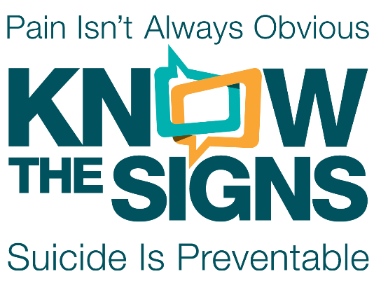

Social Media Written Post Guide (English)

Utilize this Social Media Written Post Guide for help with planning, scheduling, and posting on Twitter, Instagram, Facebook, and other social media platforms. We have grouped the available social media posts and their suggested captions into the following themes:

- Suicide Prevention Week and World Suicide Prevention Day
- Suicide Prevention Week Activity Challenge
- Know the Signs
- Find the Words
- Reach Out
- Breathe, Coping and Self Care
- For Diverse Communities

You can download all the images, animations, and videos here: https://www.suicideispreventable.org/social-media.php

For questions, please email info@suicideispreventable.org

Suicide Prevention Week and World Suicide Prevention Day

These written posts geared towards Suicide Prevention Week and World Suicide Prevention Day can be paired with the static posts provided below. You can download all the images, animations, and videos here.

National Suicide Prevention Week is a time in which individuals, organizations and communities around the country join their voices to broadcast the message that everyone can play a role in suicide prevention. Join in this year by visiting suicideispreventable.org to view, download, and share activities and resources. #SuicidePrevention #SuicidePreventionWeek | #SuicidePreventionWeek is Sept 5th – 11th. This year’s special focus is on ‘Transitions’. Transitions can be conceptualized as an event or series of events that causes fundamental changes in the fabric of daily life – what people do, where they do it, and with whom. While the COVID-19 pandemic has brought fundamental changes for people around the world, it has also strengthened our resilience and resolve. Together we can reconnect, reenter, and rebuild for the future. Visit https://www.suicideispreventable.org/prevention-kit.php to view and download activities and resources. #SuicidePrevention #SuicidePreventionWeek | On September 10th, every year, World Suicide Prevention Day provides the opportunity for people, across the globe, to raise awareness of suicide and suicide prevention. Please join us in honoring those we have lost to suicide and to spread hope to those who are currently struggling by lighting a candle 🕯 🕯 🕯 in your window at 8PM on 9/10. We are hoping to share pictures symbolizing hope across California. #SuicidePreventionWeek #WorldSuicidePreventionDay #SuicidePrevention
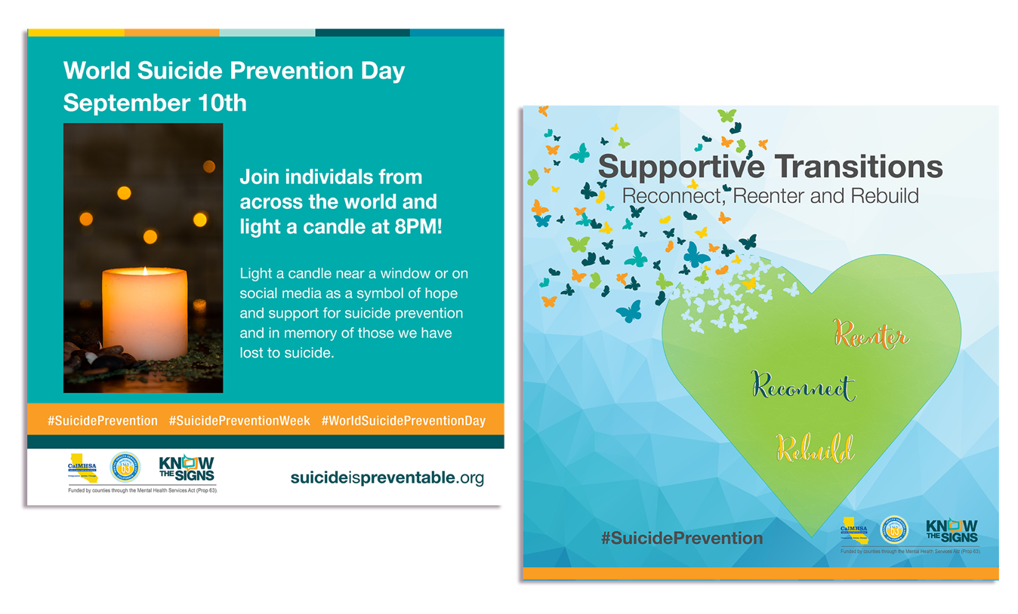

Suicide Prevention Week Challenge

These written posts were created to help you promote the Suicide Prevention Week Activity Challenge.

General: Wondering how to get involved in Suicide Prevention Week and World Suicide Prevention Day? Join in the “Reconnect” Activity Challenge! The challenge will take you through a series of five activities where you’ll connect with others, practice self-care, raise awareness and expand your suicide prevention knowledge. Review, complete, and share your finished challenges for a chance to win a Mental Health Thrival Kit. Learn more at suicideispreventable.org/prevention-kit.php. #SuicidePrevention #Reconnect  Challenge #1  Today marks the official kick-off of the Suicide Prevention Week “Reconnect” Activity Challenge! Today’s challenge is focused on reconnecting and creating a safe space, something everyone can do to play a role in suicide prevention. Take some time today to reach out to someone in your life and create a safe space, letting them know that you are comfortable to talk about anything they need, including suicide. Learn more at suicideispreventable.org/prevention-kit.php. #SuicidePrevention #Reconnect | Challenge #2  Today’s Suicide Prevention Week “Reconnect” Activity Challenge is all about having fun while learning more about suicide prevention! Join in by completing Find the Words Cross Word Puzzle and posting a picture!  Learn more at suicideispreventable.org/prevention-kit.php. #SuicidePrevention #Reconnect #Crossword  Challenge #3  It’s not too late to join the Suicide Prevention Week “Reconnect” Activity Challenge. To get started download the challenge flyer and card at suicideispreventable.org/prevention-kit.php. For today’s challenge we ask that you familiarize yourself with a suicide prevention resource. Visit their website or social media page and like, share or comment to show your support for the work they do. #SuicidePrevention #Reconnect | Challenge #4  Today’s Suicide Prevention Week “Reconnect” Activity Challenge is focused on a simple, but profound coping skill: Breathing. Schedule a 10-minute ‘Breathe Break’ into your calendar and use this time to remove distractions and partake in a breathing exercise of your choice. This can be done individually, during a zoom meeting, or even as a family! Learn more at suicideispreventable.org/prevention-kit.php. #SuicidePrevention #Reconnect  Challenge #5  It is World Suicide Prevention Day! Observed each year on September 10th, On this special day, complete the fifth Suicide Prevention Week “Reconnect” Activity Challenge by joining thousands of others in showing your support for suicide prevention and to remember loved ones lost to suicide by lighting a candle near a window or sharing on social media at 8PM. Learn more at suicideispreventable.org/prevention-kit.php. #SuicidePrevention #Reconnect

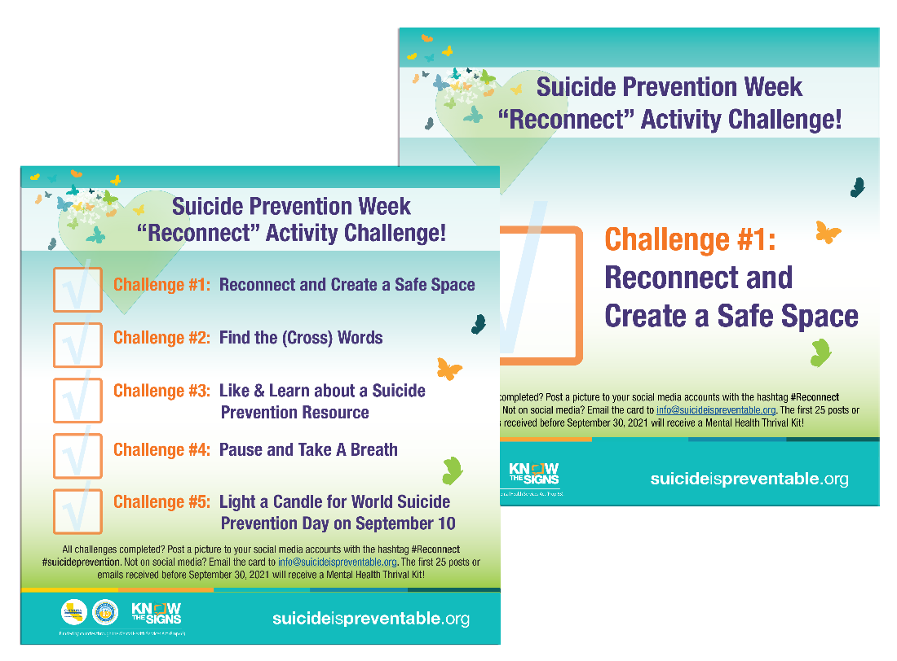

Know the Signs

These written posts focus on Knowing the Signs for suicide and can be paired with any of the displayed static images, word animations (15 and 28-seconds), and videos (34-seconds) that can be downloaded here.
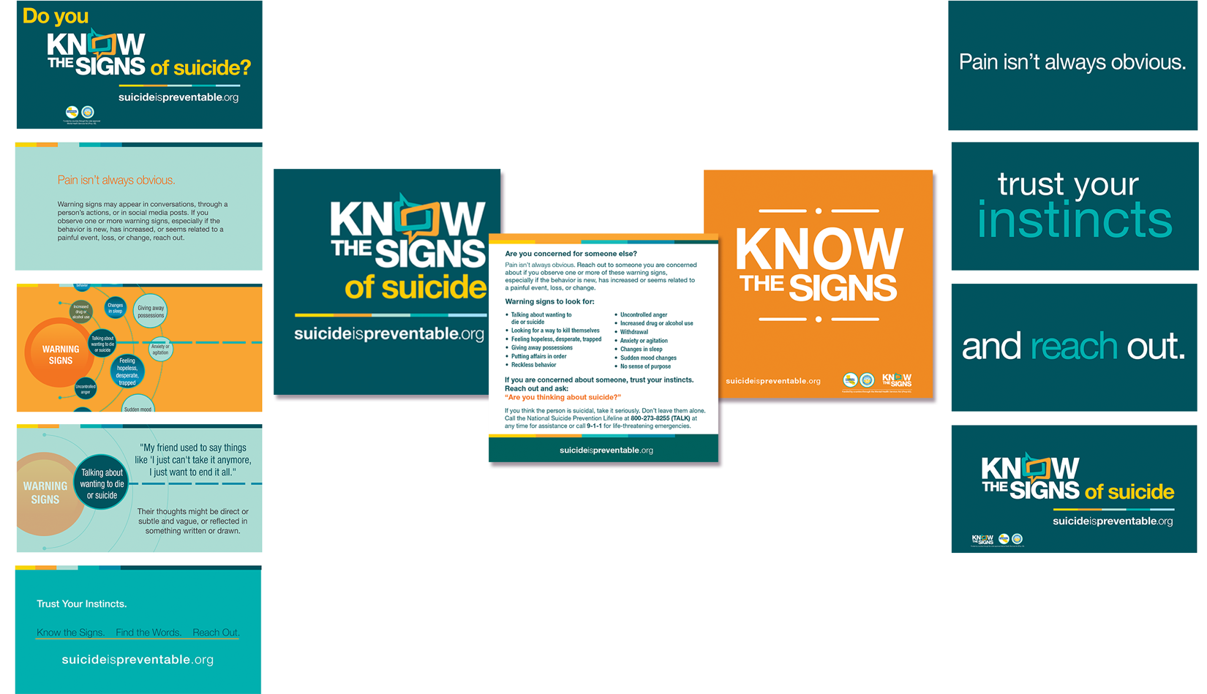
Pain isn’t always obvious, but most people show some signs when they are thinking about suicide. Warning signs may appear in conversations, through a person’s actions, or in social media posts. If you observe one or more warning signs, especially if the behavior is new, has increased, or seems related to a painful event, loss, or change, reach out. Learn more at suicideispreventable.org #SuicidePrevention  By recognizing the signs, finding the words to start a conversation, and reaching out to local resources, you have the power to make a difference. The power to save a life. Learn more at suicideispreventable.org #SuicidePrevention | Is someone you care about not acting like themselves? If you’re worried about someone, the best thing that you can do is to trust your instincts and speak up! Remember you are not alone. Call the National Suicide Prevention Lifeline at 1-800-273-8255 if you are concerned about a loved one or in crisis yourself. To learn more about the warning signs for suicide and tips to prepare for a conversation with someone you are concerned about visit suicideispreventable.org #SuicidePrevention | Even with friends and family around, someone experiencing emotional pain or suicidal thoughts can feel isolated. You may sense something is wrong, but not realize how series it is. Trust your instincts and reach out, especially if the behavior is new, has increased or is related to a painful event, loss or change. The warning signs for suicide include sudden mood changes, withdrawal, changes in sleep, feelings of hopelessness, talking about wanting to die, putting affairs in order, feeling trapped, reckless behavior, and increased drug and alcohol use. Learn more warning signs at www.suicideispreventable.org  #SuicidePrevention

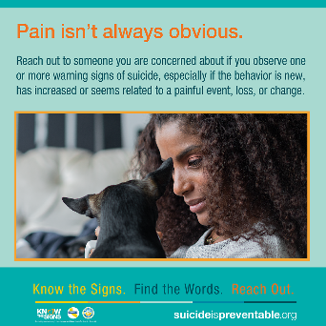
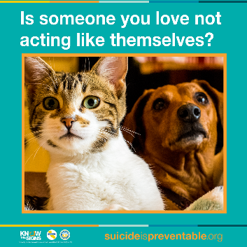

Know the Signs, continued

This post can be used with either of the 15-second or 28-second animation video below. You can download all the images, animations, and videos here.

Every day in California there are men with deep hidden emotional wounds, some are thinking about suicide. Men aren’t indestructible and often they don’t know how to ask for help, even when they need it. We expect them to keep us safe, but who’s looking out for them. Pain isn’t always obvious and can be strong enough to crack any rock. Trust your instincts and learn the signs, visit www.suicideispreventbale.org to recognize the signs, find the words and reach out. Find the courage to have the conversation, you have the power to make a difference, the power to save a life. #suicideprevention
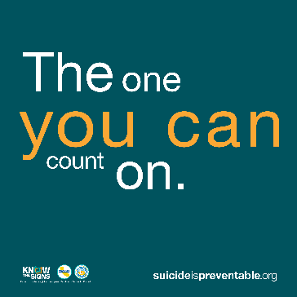

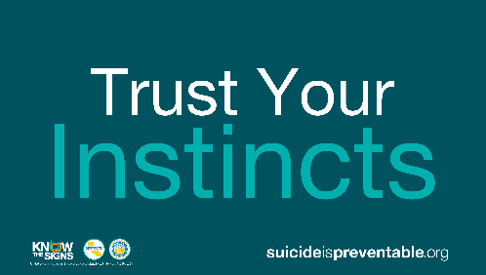

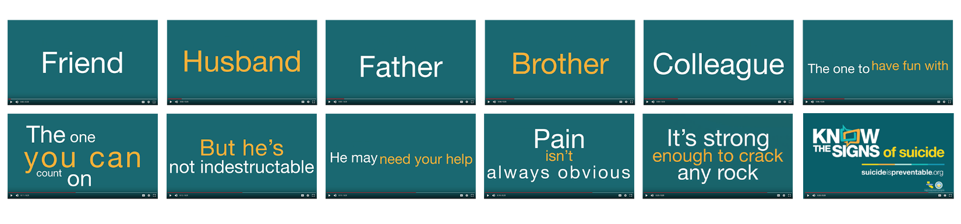

Actual video does not have this typo!

Know the Signs, Continued

These written posts focus on Knowing the Signs for suicide and are meant to be paired with the specific static and video posts below. Note, the 60-second videos displayed below are ‘inset’ into the graphic post and can be used on social media or PowerPoint presentations. You can download all the videos here.

This moving personal story is about a veteran who returns from combat with post-traumatic stress disorder (PTSD). He shares his suicide attempt and other struggles associated to his mental illness. Through counseling and supportive family and friends, he recovered and now works for a nonprofit that helps veterans get the help they need. Remember, you are not alone. #SuicidePrevention #Veterans #PTSD  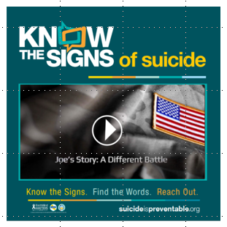 | 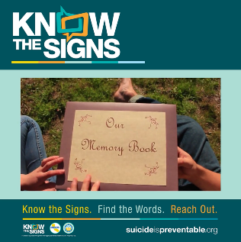  This powerful film comes from the Directing Change Program, which hosts a film contest each year to elevate youth voices and raise awareness around mental health and suicide prevention. “A New Tomorrow” tells a story through a memory book, where a boy reflects on the changes he noticed in his friend and how he got her the support she needed. Remember, you are not alone. #DirectingChange #SuicidePrevention | “Recognizing the signs, starting a conversation, and knowing where to turn for help gives you the power to make a difference, the power to save a life.” The film “The Signs” depicts a girl who takes the signs of suicide seriously and stops to get help. It serves as a reminder that the signs shouldn’t be ignored and that reaching out is the best step to take. Remember, you are not alone. #DirectingChange #SuicidePrevention  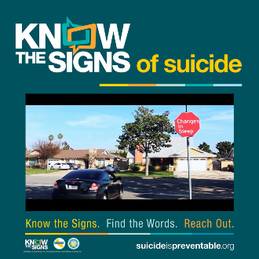

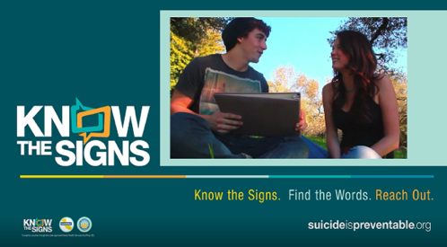
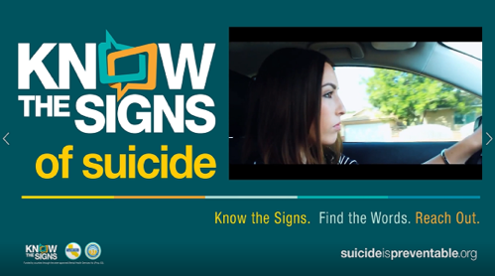
Find the Words

These written posts focus on Finding the Words for suicide and can be paired with any of the displayed static images. If you are posting these on Instagram you can you the images as a two-part story. You can download all the images, animations, and videos here.

If you’re worried about someone mention the behaviors, you have been noticing and ask directly about suicide. Saying the words directly, “Are you thinking about suicide?” can be difficult to say, but when it comes to suicide prevention, none are more important. Remember you are not alone. Call the National Suicide Prevention Lifeline at 1-800-273-8255 if you are concerned about a loved one or in crisis yourself. #SuicidePrevention | Is someone you care about not acting like themselves? If you’re worried about someone, the best thing that you can do is to trust your instincts and speak up! Remember you are not alone. Call the National Suicide Prevention Lifeline at 1-800-273-8255 if you are concerned about a loved one or in crisis yourself. To learn more about the warning signs for suicide and tips to prepare for a conversation with someone you are concerned about visit suicideispreventable.org #SuicidePrevention  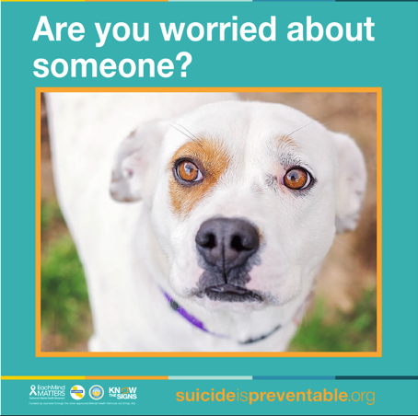 | If you are concerned about someone, trust your instincts! Reach out and ask about suicide directly. Remember, talking about suicide does not put the idea in someone’s head, rather it provides an opportunity for them to open up and talk about their distress. Visit suicideispreventable.org to learn about various ways to start the conversation. #SuicidePrevention  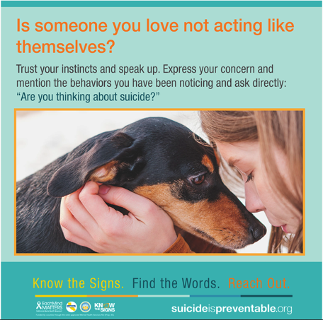
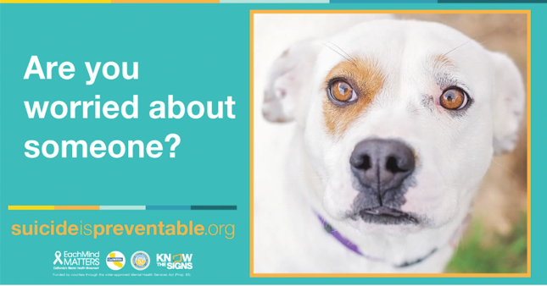

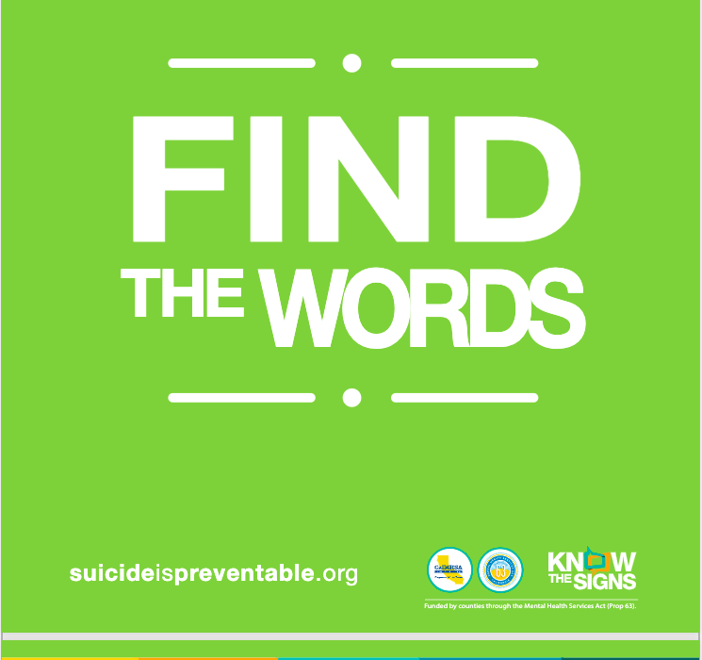
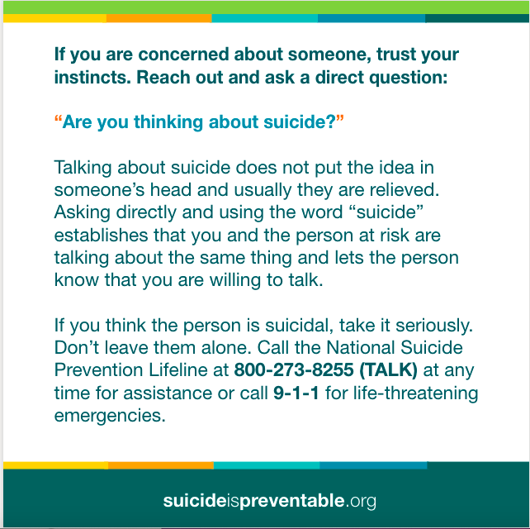
Find the Words, Continued

These written posts focused on Finding the Words for suicide and is meant to be paired with the specific video posts below. Note, the 60-second videos displayed below are ‘inset’ into the graphic post and can be used on social media or PowerPoint presentations. You can download all the videos here.
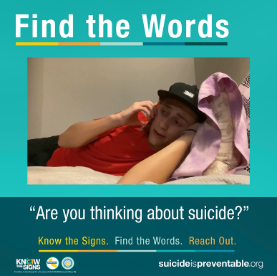
A girl who experienced thoughts of suicide reflects on how her friends noticed the signs and reached out to help her when she needed them most. If you’re worried about someone, the best thing that you can do is to trust your instincts and speak up! Mention the behaviors you have been noticing and ask directly about suicide. Saying the words directly, “Are you thinking about suicide?” can be difficult to say, but when it comes to suicide prevention, none are more important. And remember, you are not alone. Call the National Suicide Prevention Lifeline at 1-800-273-8255 if you are concerned for someone or need help yourself. #DirectingChange #SuicidePrevention | This film encourages the viewer to directly ask someone who shows warning signs if they are thinking of suicide. The film, called “Unrecognizable Thoughts,” explains that asking someone if they’re thinking about suicide is important and that “you may have to break a friend’s trust to help them.” To learn more about the warning signs for suicide and tips to prepare for a conversation with someone you are concerned about visit suicideispreventable.org #DirectingChange #SuicidePrevention | A girl who is concerned about the changes she notices in her friend asks, “Are you thinking of suicide?” She then offers to call the National Suicide Prevention Lifeline together. Asking the question directly is important, and remember, you are not alone. If you’re concerned for someone or need help for yourself, you can call the National Suicide Prevention Lifeline at 1-800-273-8255. #DirectingChange #SuicidePrevention  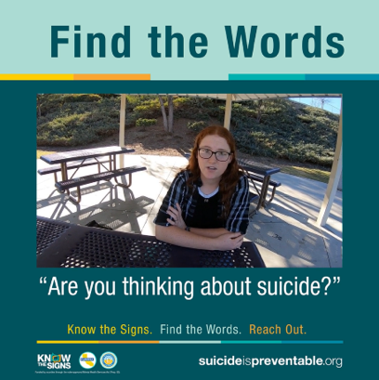
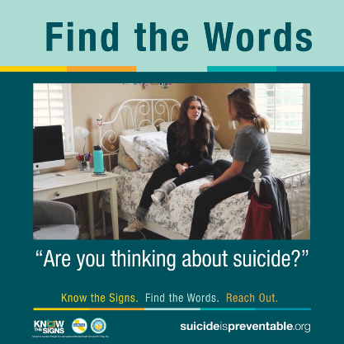

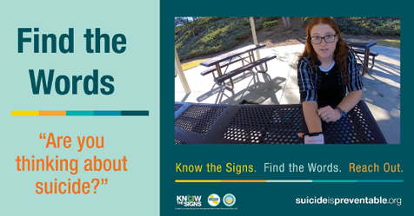
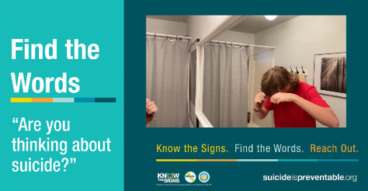

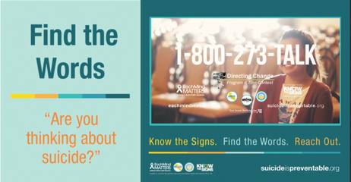

Reach Out

These written posts focus on Reaching Out if you or someone you know needs help and can be paired with the static or 60-second inset video posts below. You can download all the images, animations, and videos here.

Are you worried about someone? Know that you are not alone in helping someone in crisis. There are many resources available to assess, treat, and intervene. Crisis lines, counselors, intervention programs and more are available to you, as well as to the person experiencing the emotional crisis. Visit suicideispreventable.org to learn about a variety of resources #SuicidePrevention  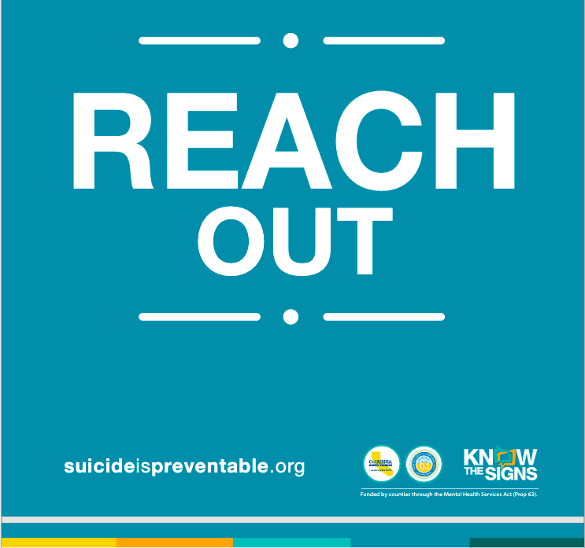 | 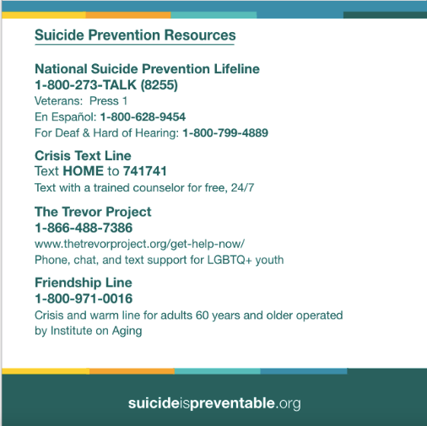  If you or someone you know needs help, Reach Out! Before having the conversation with someone you are worried about, become familiar with the resources that are available such as the 24/7 Free & Confidential National Suicide Prevention Lifeline: 1-800-273-TALK (8255). Visit suicideispreventable.org to learn about a variety of more resources. #SuicidePrevention | “Speak Out” is a youth-focused film where a boy reaches out to a trusted adult with concerns about his friend. Speaking up when you notice changes in someone can get them needed help and even has a potential to save a life. Teens can call Teen Line at 1-800-852-8336 from 6 to 10 p.m. PST or text TEEN to 839863 from 6 to 9 p.m. PST to confidentially talk to a peer about anything – no problem is too small, too large, or too shocking for Teen Line volunteers.  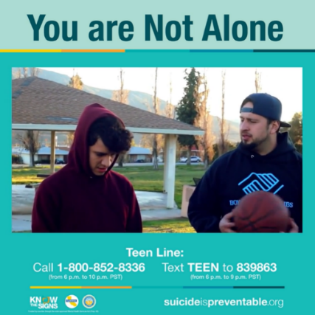
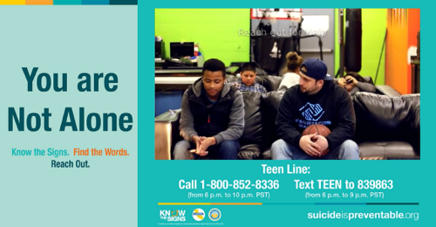
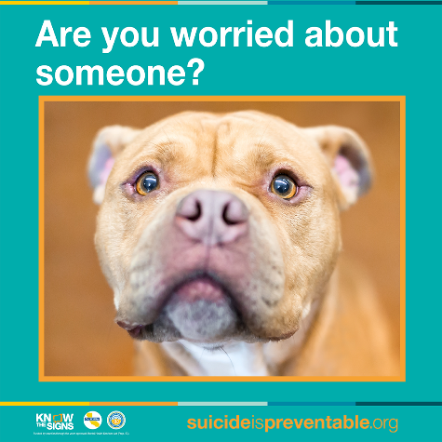

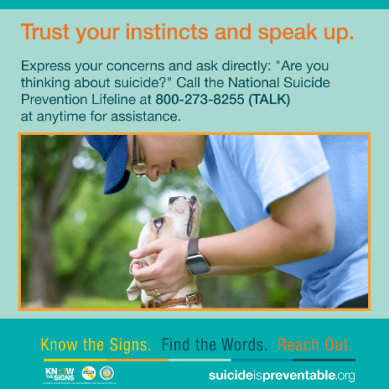

Reach Out, Continued
These written posts focus on Finding the Words for suicide and are meant to be paired with the specific video posts below. Note, the 30-second videos displayed below are ‘inset’ into the graphic post and can be used on social media or PowerPoint presentations. You can download all the videos here.

In “True Colors,” a friend brings color back into someone’s life by getting them the help that they need and staying by their side. The narrator shares that she’s glad she reached out, because over time her friend becomes more relaxed and happier. You can get connected to help by calling the free and confidential National Suicide Prevention Lifeline at 1-800-273-8255. #DirectingChange #SuicidePrevention  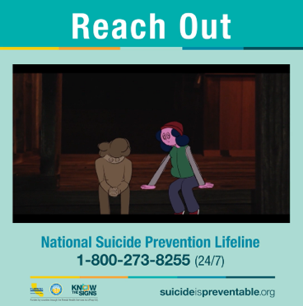 | In the film “Endless Space,” an astronaut feels alone in space while dealing with suicidal thoughts but reaches out and receives help from a friend. The film acknowledges that it can be difficult to reach out, but it’s possible for everyone to do. “There are people who care. Be the one to reach out,” the narrator says. To learn more about the warning signs for suicide and tips to prepare for a conversation with someone you are concerned about, visit suicideispreventable.org #DirectingChange #SuicidePrevention  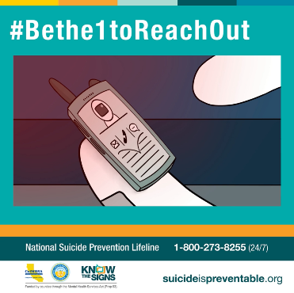 | “I know my life and yours is unique, special, and wonderous.” The mixed media film “Dandelion” shows that if you reach out when you’re struggling, someone will be there to listen. That includes crisis lines, counselors, intervention programs, and more that is available. Visit suicideispreventable.org to learn about a variety of resources you can reach out to. #DirectingChange #SuicidePrevention  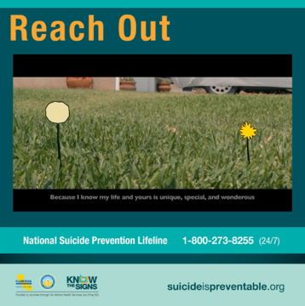

Breathe, Coping and Self-Care

These written posts focus on promoting awareness of breathing, coping and self-care exercises are written to go along with the images shown below. You can download all the images, animations, and videos here.

We ALL possess a readily available and free tool that can be used to manage stress in the moment – Our Breath. Breathing exercises can be an exceptional coping and self-care tool that have been found to be effective at reducing stress in our lives.  We are more resilient and more able to handle life’s stress when we are feeling our best both physically and emotionally. Making time to routinely practice self-care, despite how big our to-do-list may be is an important aspect of stress management. Take time today, even if it is only 5 minutes, to practice a self-care tool that works for you. #SuicidePrevention #SelfCare  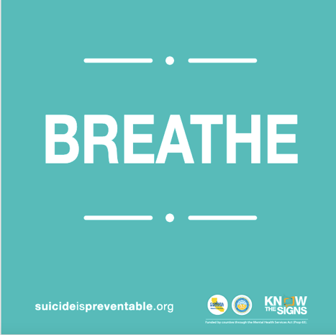 | Pause what you are doing and take a moment to practice the 4-7-8 breathing technique! Breathing exercises have been found to not only be effective at reducing stress in our lives, but they are also remarkably easy to learn. #SuicidePrevention #SelfCare  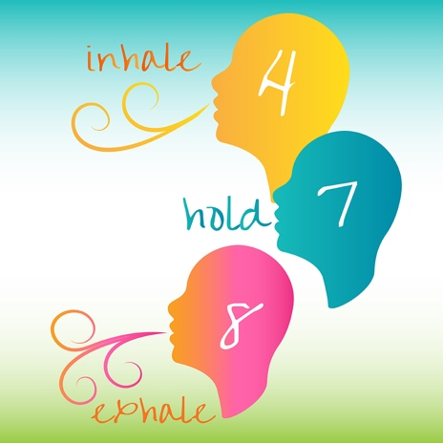 | Breathing exercises can shift your current feelings, connect you more deeply with your body, calm your nervous system and decrease stress! There are a variety of different breathing exercises, allowing you to find one or a few that work for you. One of the most common exercises is referred to as square breathing which is the act of breathing in the form of a square! Test it out today, inhale 2…3…4… hold 2…3…4! #SuicidePrevention #SelfCare  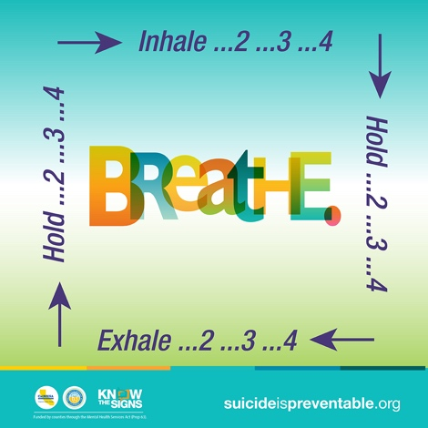

Breathe, Coping and Self-Care, continue

These written posts go along with the static posts and video animations shown below.

Color breathing is one of the many easy to learn breathing techniques that can be used to reduce stress, improve our oxygen intake, and manage anxiety. What’s color breathing? Visualize a color that represents how you want to feel, imagine inhaling that color in. Visualize a color that represents what you want to let go of, imagine exhaling that color out. Comment below what colors you are visualizing! #SuicidePrevention #SelfCare | It may sound strange, but many people forget how to breathe properly, using their chest and shoulders to breathe, resulting in short and shallow breaths which can increase stress and anxiety! When you breathe, your belly should expand, involving your diaphragm, a large muscle in your abdomen. This type of breathing is known as diaphragmatic breathing and can lower stress levels, reduce blood pressure, lower our heart rate, and help us relax. Take a moment to practice your ‘Belly Breathing’ today! #SuicidePrevention #Selfcare | Prolonged crises, such as the ones we have experienced due to COVID, often lead to long-term stress, which can be amplified among people who were already experiencing significant life challenges, chronic health or mental health conditions and disabilities. Incorporating a dose of self-care into our daily habits can have a strong impact on both our physical and mental health. Everyday take a moment (or more!) to take care of yourself. #SuicidePrevention #Selfcare
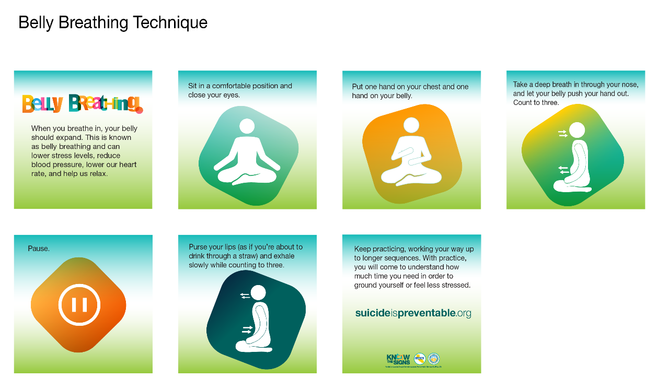

For Diverse Communities

This written post focuses on suicide prevention for diverse communities. Posts can be paired with the accompanying static images in a variety of languages, including Hmong, Khmer, Korean, Lao, Mandarin/Chinese, and Vietnamese. There is also a 36-second animation that includes all the posts. You can download all the images, animations, and videos here.
You are not alone in helping someone in crisis. There are many resources available to help you support someone you are concerned about. Having the knowledge and resources to help the ones we care about is important for each and every one of us. Visit EMMResourceCenter.org to see a collection of resources in a variety of different languages including Hmong, Khmer, Korean, Lao, Mandarin/Chinese, Punjabi, Russian, Spanish, Tagalog, and Vietnamese. #SuicidePrevention
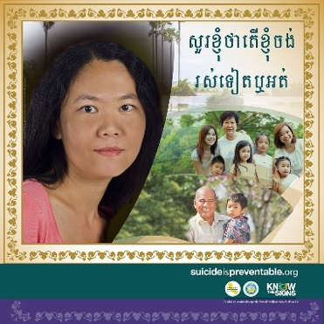  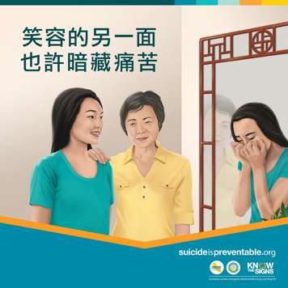  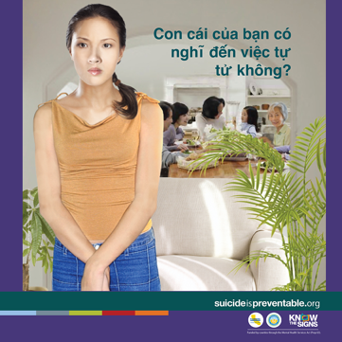  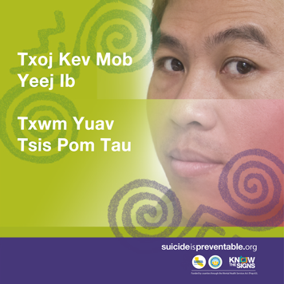  SP Vietnamese Static (png) - Adult  SP Vietnamese Static (png) - Youth  SP Chinese Static (png)  SP Khmer Static (png) | 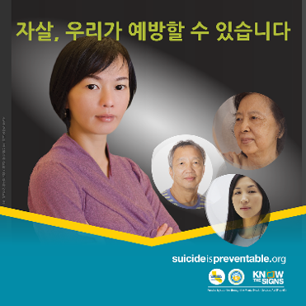  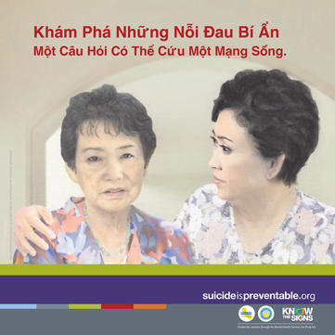 | 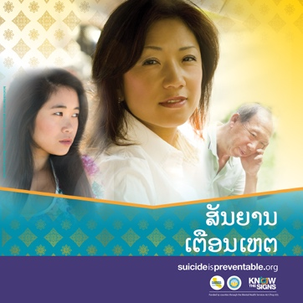  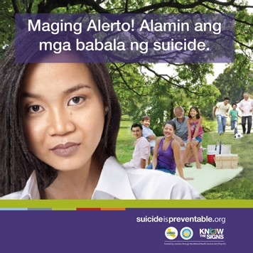  SP Tagalog Static (png)
SP Hmong Static (png)

SP Korean Static (png)

SP Lao Static (png)

For Diverse Communities, Continued

These written posts focus on suicide prevention for diverse communities. These written posts are meant to be paired with the specific video posts below. Note, the video displayed below are ‘inset’ into the graphic post and can be used on social media or PowerPoint presentations. You can download all the videos here.
A girl reflects on her friends’ mental health and the resources that are available for them to reach out to, such as a teacher, counselor, family, and hotline. You can get connected to help by calling the free and confidential National Suicide Prevention Lifeline in Spanish at 1-800-628-9454 or visiting suicideispreventable.org. #DirectingChange #SuicidePrevention  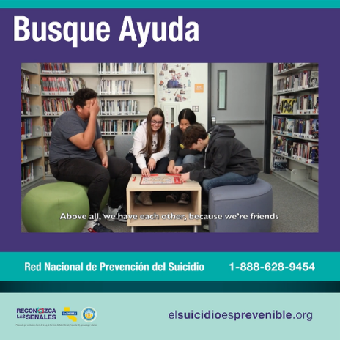  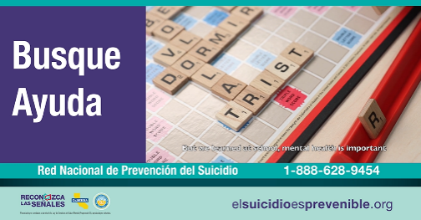  Our Words / Nuestras Palabras 60-second Inset Video (mp4) – Spanish-Speaking Youth | In “Worthy Life,” a boy talks about his hopes for the future and how his brother supports him. To learn more about the warning signs for suicide and tips to prepare for a conversation with someone you are concerned about, visit suicideispreventable.org. You can also visit EMMResourceCenter.org to see a collection of resources in a variety of different languages, including Hmong. #DirectingChange #SuicidePrevention  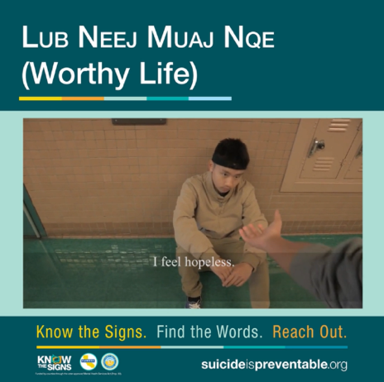  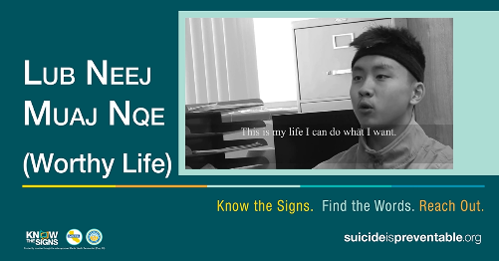  Worthy Life 60-second Inset Video (mp4) – Hmong Youth | A girl reflects on cultural expectations and how friends reached out to her in the film “Time to Speak Up.” The Hmong-language film provides resources for the viewer, including the National Suicide Prevention Lifeline. You can call 1-800-273-8255 to reach the Lifeline or visit suicideispreventable.org. #DirectingChange #SuicidePrevention  Time to Speak Up 60-second Inset Video (mp4) – Hmong Youth  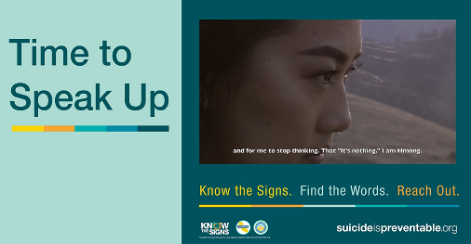  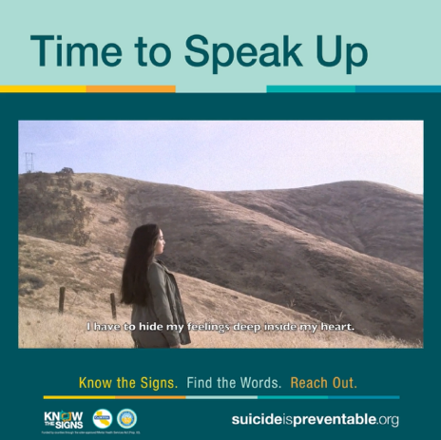

For Diverse Communities, Continued

These written posts focus on suicide prevention for diverse communities. These written posts are meant to be paired with the specific video posts below. Note, the video displayed below are ‘inset’ into the graphic post and can be used on social media or PowerPoint presentations. You can download all the videos here.
A girl decides to stop hiding her feelings and instead talks to her friends about her mental health. She then reaches out to the National Suicide Prevention Lifeline at 1-800-273-8255. Don’t be afraid to tell someone how you feel. You can call the number or visit suicideispreventable.org. #DirectingChange #SuicidePrevention  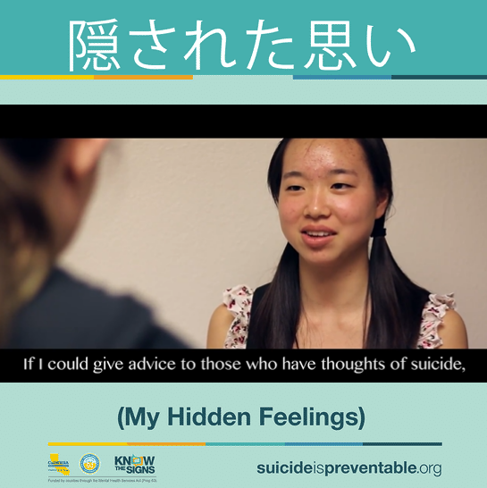  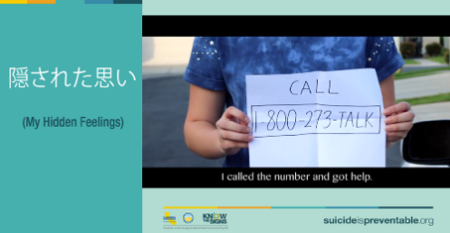  隠された思い (My Hidden Feelings) (mp4) – Japanese Youth | In the film “Reading the Signs” a boy talks about how his friends noticed that he wasn’t doing well and helped him reach out to the National Suicide Prevention Lifeline. The film encourages viewers to be open about their mental health and reach out to someone who is struggling. If you notice changes in a friend or loved one, you can call 1-800-273-8255 or visit suicideispreventable.org. #DirectingChange #SuicidePrevention  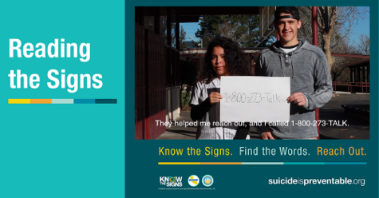  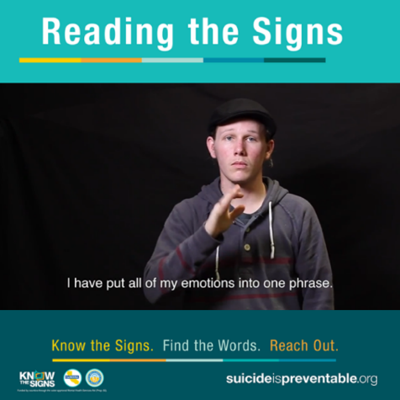  Reading the Signs 60-second Inset Video (mp4) – American Sign Language | This short film shows that depression affects people from all cultures and that we should come together to help one another. If you see some of these changes in someone, visit suicideispreventable.org to learn about the warning signs for suicide. You can also visit EMMResourceCenter.org to see a collection of resources in a variety of different languages. #DirectingChange #SuicidePrevention  Depression Has No Culture (mp4) (various languages)  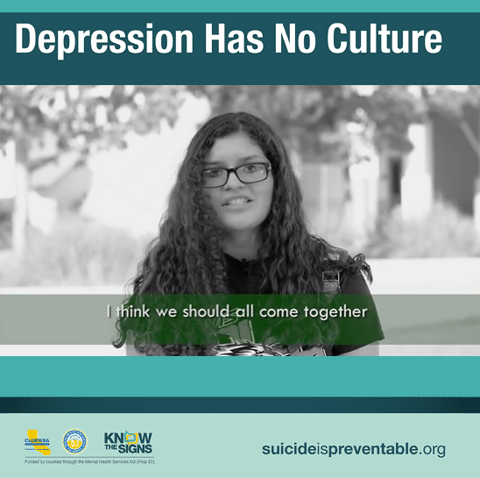  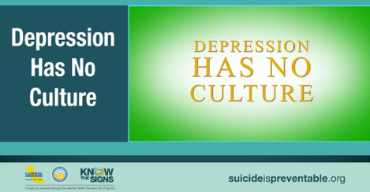

For Diverse Communities, Continued

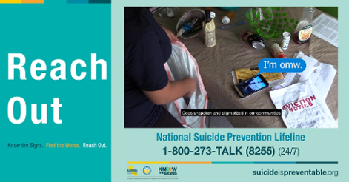
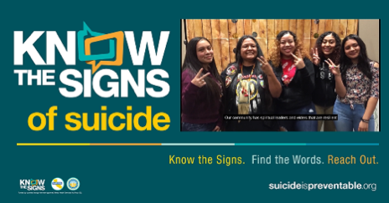
These written posts focus on suicide prevention for diverse communities. These written posts are meant to be paired with the specific video posts below. Note, the video displayed below are ‘inset’ into the graphic post and can be used on social media or PowerPoint presentations. You can download all the videos here.
“We all have the power to stop suicide in our own communities.” The film “We Are” reflects on the resilience and strength of Native American communities and where to find help. If you’re worried about someone, the best thing that you can do is to trust your instincts and speak up! Call the National Suicide Prevention Lifeline at 1-800-273-8255 if you are concerned about a loved one or in crisis yourself.  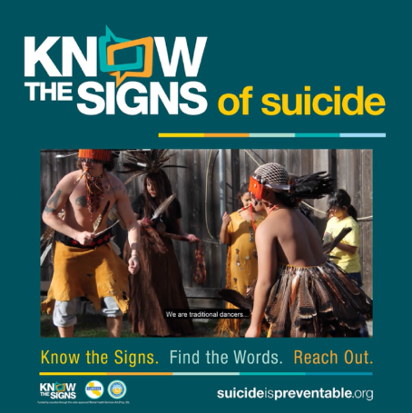  We Are 60-second Inset Video (mp4) – Native American Youth | In this film, Native youth discuss how their culture, language, family, and ceremony can heal and restore their people to help prevent suicide on Indian country. Remember you are not alone. Call the National Suicide Prevention Lifeline at 1-800-273-8255 if you are concerned about a loved one or in crisis yourself. #DirectingChange #SuicidePrevention  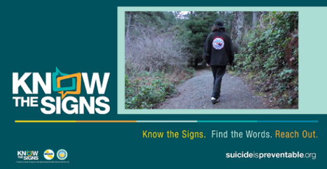  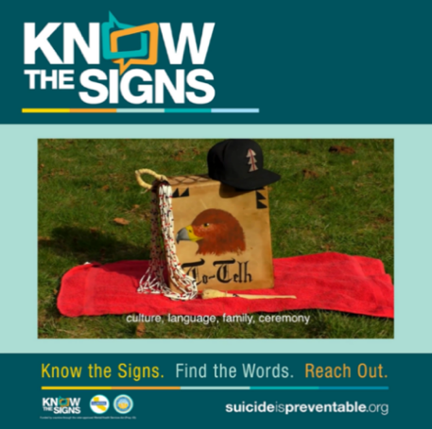  Suicide on Indian Country 60-second Inset Video (mp4) – Native American Youth | “Good Medicine” is a film from the perspective of Native American culture which highlights the healing ways in which Native cultural practices can help those experiencing addiction and mental health challenges. If you’re concerned about someone you know, there are many resources available, such as the 24/7 Free & Confidential National Suicide Prevention Lifeline (1-800-273-8255) and suicideispreventable.org.  Good Medicine 60-second Inset Video (mp4) – Native American Youth  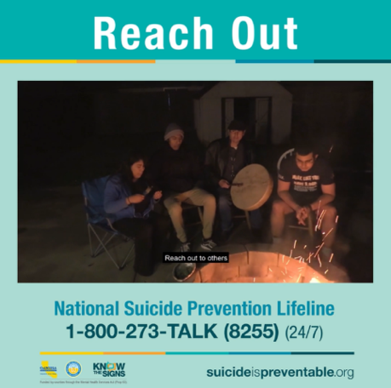

For Diverse Communities, Continued

These written posts focus on suicide prevention for diverse communities. These written posts are meant to be paired with the specific video posts below. Note, the video displayed below are ‘inset’ into the graphic post and can be used on social media or PowerPoint presentations. You can download all the videos here.

“While it may seem as though this path is a lonely and quiet one, you are not alone.” This film is about how mental health is not always spoken about in Arab households, but that support is available. If you’re concerned about a family member or friend, you can visit suicideispreventable.org or the National Suicide Prevention Lifeline at 1-800-273-8255. #DirectingChange #SuicidePrevention  Arab Hearts 60-second Inset Video (mp4) – Arab Youth | In “Discovering May,” a transgender woman shares her journey of discovering her identity. The filmmakers said, “With a story of perseverance and resilience, we hope to share her story to inspire many others to be themselves without consequence.” LGBTQ+ youth can call or text The Trevor Project at 1-866-488-7386 or visit www.thetrevorproject.org/get-help-now/ for support. #DirectingChange #SuicidePrevention  Discovering May 60-second Inset Video (mp4) – LGBTQ+ Youth | “The sun always rises so the darkness never lasts.” This powerful film, “Pain Never Lasts,” uses spoken word to share the artist’s hope, even in dark times. Don’t be afraid to speak up if you’re experiencing thoughts of suicide. You can get connected to help by calling the free and confidential National Suicide Prevention Lifeline at 1-800-273-8255. #DirectingChange #SuicidePrevention  Pain Never Lasts 60-second Inset Video (mp4) – African American youth
