Mental Health Matters Month: Organic Social Media Posting Guide
This May, to spread awareness and promote Mental Health Matters Month (MIMHMM), we encourage sharing all of the provided content to your county or city’s social media profiles throughout the month. The files for each image can be found here for your use. Both the static JEPG and working (editable) files can be downloaded, if you would like to add your county/city logo or make any other customizations please use the working (editable) files.
Based on social media best practices, such as when people are most active online, we have outlined the recommended days/times for each post. All of the content shown in this guide will be shared across CalMHSA’s Take Action for Mental Health social channels, which gives the option to reshare those as well.
Take Action for Mental Health social channels:
- Facebook
- Instagram
- Twitter
Suggested Posting Schedule
Below is the content for each platform (Instagram, Facebook, and Twitter) along with the recommended days and windows of time to schedule each post. Feel free to include additional hashtags to the copy (local hashtags, etc). Please note there are alternate images for the 18th and 23rd if you prefer to use images that include masked individuals.

Instagram
May 2 | May 5
10 AM - 12 PM | 2 PM - 4 PM
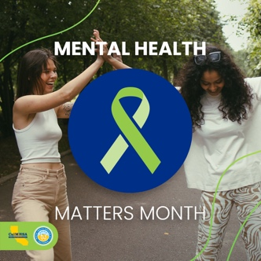  May is #MentalHealthMattersMonth! You can Take Action For Mental Health by finding out how to #CheckIn, #LearnMore, and #GetSupport for yourself or anyone you know who is in a mental health crisis. Visit https://takeaction4mh.com/ #TakeAction4MH | 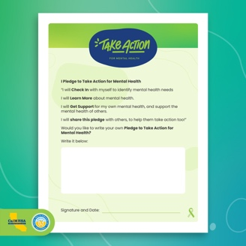  This #MentalHealthMattersMonth, make the pledge to Take Action For Mental Health for yourself, your friends, and your community. Make your pledge now at takeaction4mh.com (link in bio), and share your pledge with your network! #MakeThePledge #TakeAction4MH
May 10 | May 13
3 PM - 5 PM | 8 AM - 10 AM
  For #MentalHealthMattersMonth, you can Take Action For Mental Health by finding out how to #CheckIn on your mental health and the mental health of those you care about. Start a conversation to see how you can help or support yourself — or others. Find out how at takeaction4mh.com (link in bio) #TakeAction4MH |   Here's another action you can take for #MentalHealthMattersMonth: #LearnMore about mental health needs and explore the self-care, services, and supports available to help find a path forward. Visit takeaction4mh.com (link in bio) to get started. #TakeAction4MH
May 18 | May 23
12 PM - 2 PM | 3 PM - 5 PM
  #GetSupport for your own mental health, or help someone else find help, by reaching out and connecting with resources available in your community! Visit takeaction4mh.com (link in bio) for helpful resources. #MentalHealthMattersMonth #TakeAction4MH | 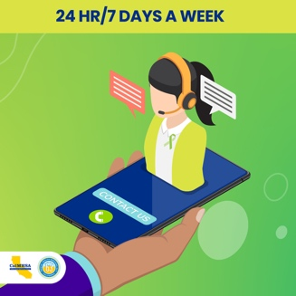  If you are in distress, need emotional support, or are worried about a loved one, help is available. You can call the National Suicide Prevention Lifeline at 1-800-273-8255 24 hours a day/7 days a week for free and confidential crisis counseling. #MentalHealthMattersMonth #TakeAction4MH
May 26 | May 31
12 PM - 2 PM | 10 PM - 12 PM
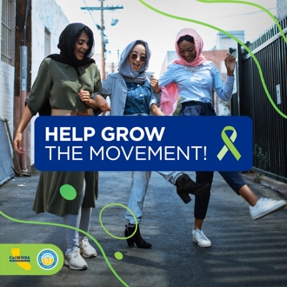  Help grow the movement to Take Action For Mental Health in California! Suggest us as a follow to friends and family, pledge to take action, and show your support for people experiencing a crisis this Mental Health Matters Month — and every month! #MakeThePledge #TakeAction4MH | 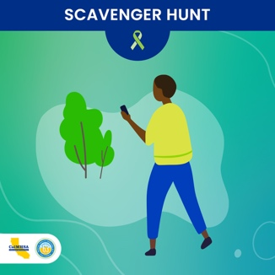  Join the #MentalHealthMattersMonth Scavenger Hunt! Get outside and discover places and activities that can help you engage in #SelfCare or support others. Visit takeaction4mh.com (or link in bio) for details.

Facebook
May 2 | May 5
10 AM - 12 PM | 2 PM - 4 PM
May is Mental Health Matters Month! You can Take Action For Mental Health by finding out how to Check In, Learn More, and Get Support for yourself or anyone you know who is in  a mental health crisis. Visit https://takeaction4mh.com/ and share this post to help grow the movement! | For Mental Health Matters Month, make the pledge to Take Action For Mental Health — for yourself, your friends, and your community. Make The Pledge now at https://takeaction4mh.com/check-in-resources/, and share your pledge with your network!
May 10 | May 13
3 PM - 5 PM | 8 AM - 10 AM
For Mental Health Matters Month, you can Take Action For Mental Health by finding out how to Check In on yourself and those you care about. Start a conversation to see how you can find help or offer support. https://takeaction4mh.com/check-in-resources/ | Here's another action you can take for Mental Health Matters Month: Learn More about mental health needs and explore the self-care, services, and supports available to help find a path forward.  https://takeaction4mh.com/learn-more-resources/
May 18 | May 23
12 PM - 2 PM | 3 PM - 5 PM
You can Get Support for your own mental health, or help someone else find help, by reaching out and connecting with resources available in your community! Take Action For Mental Health this Mental Health Matters  Month at https://takeaction4mh.com/get-support-resources/ | If you are in distress, need emotional support, or are worried about a loved one, help is available. You can call the National Suicide Prevention Lifeline at 1-800-273-8255 24 hours a day/7 days a week for free and confidential crisis counseling. https://takeaction4mh.com/find-help-now/
May 26 | May 31
12 PM - 2 PM | 10 PM - 12 PM
Help grow the movement to Take Action For Mental Health in California! Share this post with your network, pledge to take action, and show  your support for people experiencing a crisis this Mental Health Matters Month — and every month! https://takeaction4mh.com/ | Have you heard of the Mental Health Matters Month Scavenger Hunt? Get outside and discover places and activities that can help you engage in self care or support others. Visit https://takeaction4mh.com/ for details.

Twitter
May 2 | May 5
10 AM - 12 PM | 2 PM - 4 PM
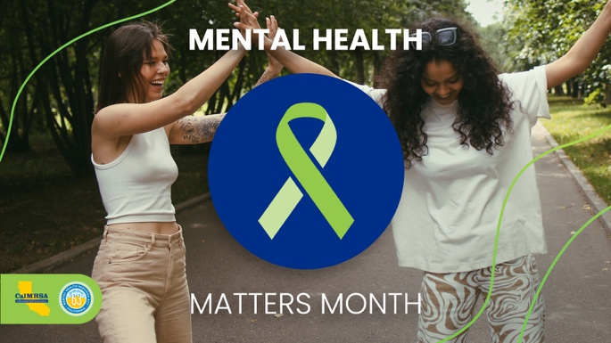  May is #MentalHealthMattersMonth! You can Take Action For Mental Health by finding out how to #CheckIn, #LearnMore, and #GetSupport for yourself or anyone you know who is in a mental health crisis. Visit https://takeaction4mh.com/ #TakeAction4MH | 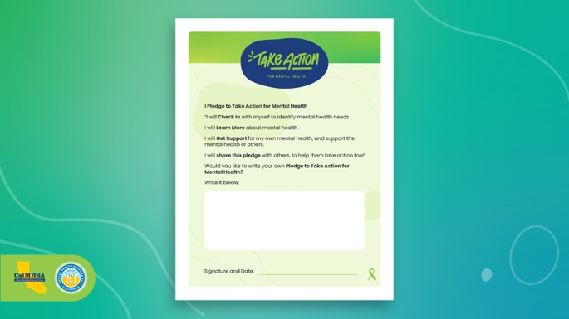  This #MentalHealthMattersMonth, make the pledge to Take Action For Mental Health for yourself, your friends, and your community. Make your pledge now at https://takeaction4mh.com/check-in-resources/, (link in bio), and share your pledge with your network! #MakeThePledge #TakeAction4MH
May 10 | May 13
3 PM - 5 PM | 8 AM - 10 AM
  For #MentalHealthMattersMonth, you can #TakeAction4MH! #CheckIn on your mental health & the mental health of those you care about. Start a conversation to see how you can help or support yourself or others. Find out how at https://takeaction4mh.com/check-in-resources/ |   Here's another action you can take for #MentalHealthMattersMonth: Learn More about mental health needs. Explore the self-care, services & supports available. Visit https://takeaction4mh.com/learn-more-resources/ to get started. #TakeAction4MH #MentalHealthAwarenessMonth
May 18 | May 23
12 PM - 2 PM | 3 PM - 5 PM
  You can Get Support for your own mental health, or help someone else find help, by reaching out and connecting with resources available in your community! Visit https://takeaction4mh.com/get-support-resources/ for helpful resources. #MentalHealthMattersMonth #TakeAction4MH | 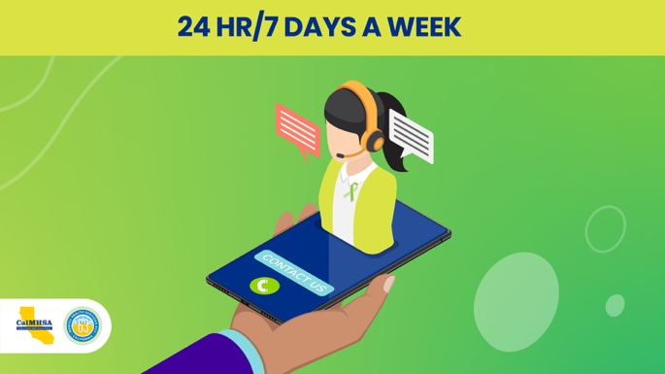  If you are in distress, need emotional support, or are worried about a loved one, help is available. Call the National Suicide Prevention Lifeline at 1-800-273-8255 24/7 for free & confidential crisis counseling. #TakeAction4MH #MentalHealthMattersMonth
May 26 | May 31
12 PM - 2 PM | 10 PM - 12 PM
  Help grow the movement to Take Action For Mental Health in California! RT to your network, Make The Pledge & show your support for people experiencing a crisis https://takeaction4mh.com/ #MentalHealthMattersMonth #TakeAction4MH | 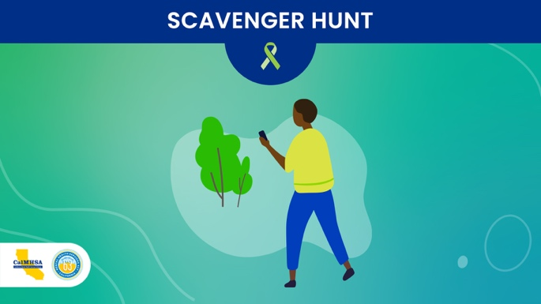  Get ready for the #MentalHealthMattersMonth Scavenger Hunt! Get outside and discover places and activities that can help you engage in Self Care or support others. More here: https://takeaction4mh.com/ #TakeAction4MH

CalMHSA’s Schedule
Below are the days and times that CalMHSA will be posting across all of Take Action for Mental Health’s social platforms. If you prefer to reshare some or all of the content, you can keep an eye out during these times to repost to your account.
May 2 | May 5 | May 10 | May 13
11:30 AM | 3 PM | 4:30 PM | 9:00 AM
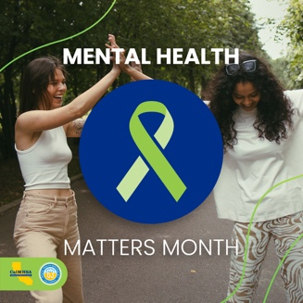 | 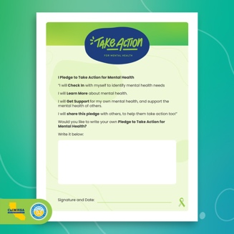 | 
May 18 | May 23 | May 26 | May 31
12:30 PM | 3 PM | 12 PM | 12 PM
 |  |  | 