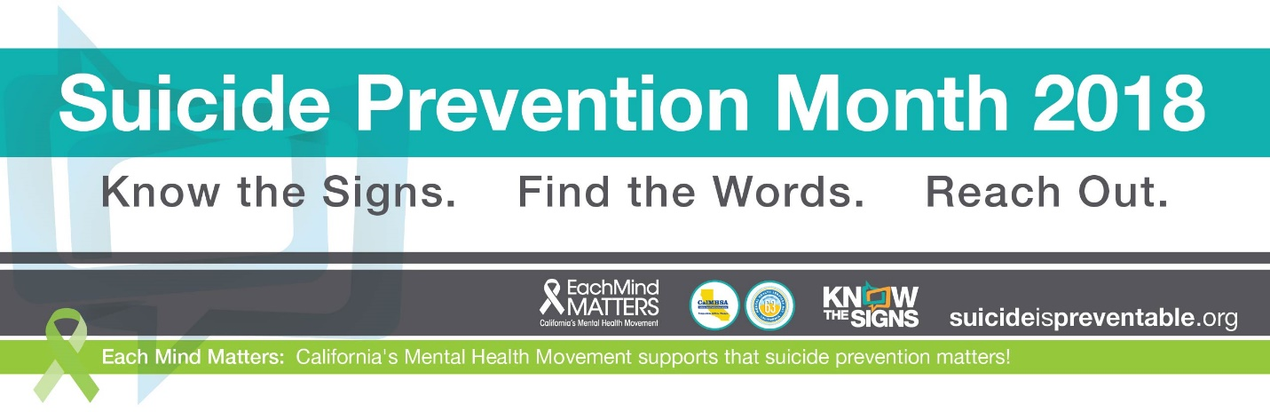
How Do I Talk to my Teenager about Suicide?
As Latino parents we often feel ill-equipped to support the myriad of challenges our children face; especially mental health ones. Many of our children face difficulties with acculturation, discrimination, bullying, depression and anxiety. This is especially true for our Latina youth; data tells us that young Latinas are at higher risk of attempting suicide than their male counter parts.
So how do we help our daughters who are hurting? While we wish we could shield them, the reality is that they may view suicide as a solution to their pain. As parents we may feel panic and fear at the mention of the word suicide, but the most important thing we can do is to stay calm and help guide them toward the resources and help they need to ease their pain and continue to live happy and productive lives. Below are some tips to prepare you for a conversation with your child about suicide.
Learn About Suicide Prevention
The first step is to find out more about the warning signs of suicide and the services and supports that are available in your area. The Reconozca las Señales website (http://www.elsuicidioesprevenible.org ) provides information in Spanish to help you identify warning signs, start a conversation with your child or loved one and where to find help. Send an email to info@suicideispreventable.org or reach out to your local behavioral health office to ask about trainings in your area.
Be Prepared
Talking to your child about suicide may seem daunting. Remember, if you come from a place of love and concern, your message will be heard. Below are some helpful tips to start the conversation.
Plan to have this conversation in a safe place during a time when you will not be distracted or pressed for time. Before starting the conversation, research available resources. Available resources include:
- The Reconozca las Señales website contains links to county resources and is a good starting point.
- The National Suicide Prevention Lifeline1-800-273-8255(English) or 1-888-628-9454 (Spanish.
- The Crisis Text Line (Text “HOME” to 741-741).
- The Reconozca las Señales website contains links to county resources and is a good starting point.
- If your child identifies as LBGTQ The Trevor Project is another good resource (1.866.488.7386)

Start the Conversation by talking about a specific warning sign you have noticed.
I noticed recently that you are withdrawn and isolated yourself from your friends. Sometimes people who isolate themselves, are thinking of suicide. Are you thinking about suicide?
Asking the question “are you thinking about suicide” will not make someone think about taking their life. Those who think about suicide have been doing so for some time—it does not happen overnight. In fact, asking them directly about suicide can be a relief.
If your child states they are not thinking about suicide, take this opportunity to discuss the topic. Ask them what they know about suicide and share what you have learned about suicide prevention. Emphasize that they can always come to you if they are having thoughts of suicide. You love them and are here to help them.
Listen and Validate Their Feelings. It can be hard not to get emotional when you learn your child is thinking about suicide. Stay calm and listen to them. Now is not the time to judge, criticize or minimize their pain. Rather, validate what they are feeling.
I can see this hurts you very much and I am here to help you.
Tell me more about what you are feeling. I want to understand how you feel.
Avoid saying things like:
I know how you feel.
This is silly, you will get over it.
Continue the Conversation by telling them you love them and are concerned about them.
I want you to know you are not alone. There is help.
You know I love you very much and want the best for you. I know of some resources where we can get help.
Connect to Resources. The resources you connect them to will depend on the conversation you have. You may decide to seek professional help and go to counseling individually or together, or schedule weekly conversations with your child to check on their mental well-being. Remind them of the hotlines and other resources you have learned about and offer to call with them. You can also call the National Suicide Prevention Lifeline yourself if you are concerned and not sure what to do.
If you believe your child is in crisis and will hurt themselves, or they may have already harmed themselves, then you must act immediately. Take them to the emergency room or call 911 for assistance.

What Else Can I Do?
Continue the conversation. Ensuring the mental well-being of our children is a lifetime endeavor.
- To reduce mental health stigma, advocate for mental health classes for your child and community.
  - Learn more about mental health at www.SanaMente.com or EachMindMatters.com.
  - View the documentary, Some Girls to learn about how issues of identify intersect with thoughts of suicide for Latina girls at http://somegirlsdoc.com.
- Encourage your child to be active. Participating in physical activity increases self-esteem and reduces depression.
Pain Isn’t Always Obvious, especially in teenagers. As parents, it’s often difficult to know if our child is going through the normal ups and downs of a teenager or if it is something more series. But if we trust our instincts as parents, we can be there for our children and provide them with the resources and help they need.

