Friday September 13: Hidden
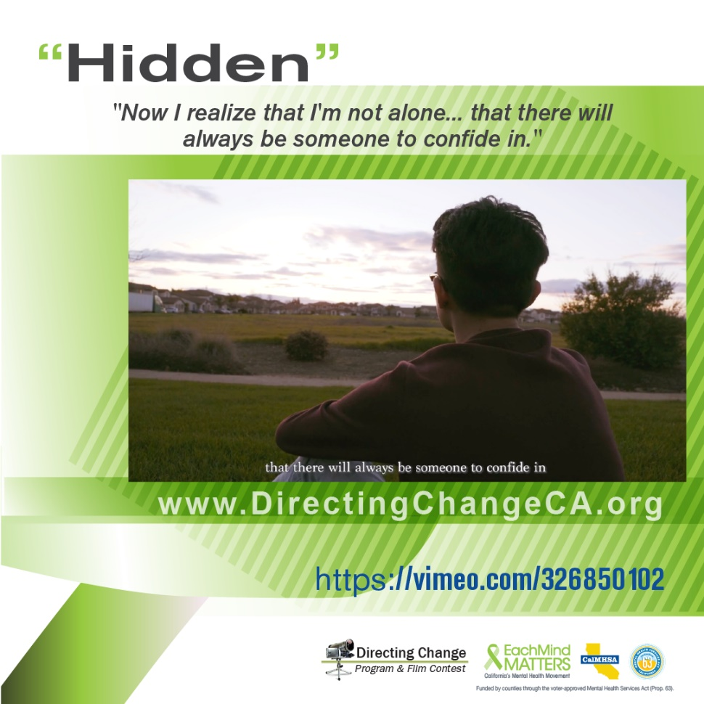

Suicide prevention efforts may look different depending on the community and the culture of people in your neighborhood. We encourage reflecting on the strengths and challenges that your community may be facing when developing suicide prevention events and materials, and to consider sharing specific resources designed for diverse communities when available. Directing Change films for diverse communities, available in numerous languages, are free to download and screen here: http://www.directingchangeca.org/diverse-communities/. In addition, suicide prevention materials in many different languages can be downloaded for free from the Each Mind Matters Resource Center at www.EMMResourceCenter.org.

For our Spanish-speaking community, this year we have an activity that is a twist on the classic Lotería game. Reconozca Las Señales Lotería follows the same rules as the traditional game, but includes cards about mental health, recognizing the signs for suicide, and resources, so all people playing can be learning while having fun together. You can access these for free on the Each Mind Matters Suicide Prevention Week Activation Kit at https://www.eachmindmatters.org/spw2019/

Highlighted Film: Hidden

Created by Ethan Ocampo & Jonathan Ocampo from Franklin High School, Sacramento County
- View film: https://vimeo.com/257978363
A Filipino boy is afraid to share his feelings because depression is not taken seriously in his culture. He fears that these emotions will be perceived as a lack of faith in God, and that he is bringing shame to his family. He decides to reach out for help.

“Now that I realize I am not alone… there will always be someone to confide in.”

- Share the film: Suicide prevention can be a taboo topic for many cultures. This film is a Filipino boy’s story about his fear in opening up because depression is not taken seriously in his culture, but he ultimately decides to reach out for help. https://vimeo.com/257978363 #SPweek #directingchange
- Language: Tagalog with English captions

About Directing Change: The Directing Change Program & Film Contest is an evaluated youth engagement program. Directing Change engages students and young people throughout California to learn about the topics of suicide prevention and mental health by creating short films that are used to support awareness, education, and advocacy efforts on these topics. Youth apply knowledge about mental health and suicide prevention to create their own unique message about suicide prevention for their peers. Through the creative process of filmmaking young people are engaged via all methods of the learning spectrum: to see, experience, discuss, and apply. These students are recognized for their efforts at a red-carpet award ceremony and their films help impact social change at their schools and in their communities. Directing Change is part of Each Mind Matters: California's Mental Health Movement and statewide efforts to prevent suicide, reduce stigma and discrimination related to mental illness, and to promote the mental health and wellness of students. These initiatives are funded by counties through the Mental Health Services Act (Prop 63) and administered by the California Mental Health Services Authority (CalMHSA), an organization of county governments working to improve mental health outcomes for individuals, families, and communities.

