Self-Care: The Importance of Loving Ourselves
Life is busier and more hectic than ever these days. This is when restoring balance in our lives is especially essential to our overall well-being and mental health. Incorporating daily self-care practices into our life requires dedication and practice. Everyday take a moment (or more) to pause and refuel yourself.
Practicing self-care can help preserve our happiness, health and productivity. Restoring balance in our personal and professional lives is a state of mind created by daily habits – connecting with others, staying positive, and creating joy and satisfaction are proven tools that can help strengthen our mental health. There are different dimensions of self-care and it is not a one-size-fits-all pursuit – we get to create our own self-care plan!
It is important to include activities and practices from each dimension into our self-care routine.
Physical: The physical dimension involves fitness, eating and sleep habits and preventive medical care. Taking care of our body will increase energy levels and can boost self-esteem. Try taking a walk during lunch breaks, scheduling a doctor’s check-up, and taking inventory of how many restful hours of sleep you are getting every night.
Mental: This involves finding the balance between stimulating your mind and letting it rest. Mental self-care will help with creativity, innovation and continual learning. Try reading a book, solving a puzzle, listening to music, and unplugging from social media.
Spiritual: Spiritual self-care can help us find more meaning in life and develop a sense of purpose. Try spending time in nature, attending a religious service/praying, practicing yoga, meditating, and volunteering.
Social: Humans are social beings and we need social connection in our lives. Activities that nurture and deepen the relationships we have with others allow for stronger bonds and help create a sense of belonging and acceptance. Try working at a coffee shop, organizing a family dinner, going to brunch with friends, and joining or starting a book club.
Emotional dimension: Nourishing emotional self-care allows for a better understanding of ourselves, the ability to cope with challenges, and develop and nourish healthy relationships. Practicing emotional self-care helps us be more compassionate with ourselves and others. Try self-reflecting in a journal, saying positive affirmations, connecting with a friend, and practicing gratitude.
Taking the time to care for ourselves allows us to help others as well. Self-care improves our mood, strengthens our immunity, and increases positive thinking. It can decrease stress, depression, and anxiety while preventing burnout. Taking care of our spirits, dealing better with difficult times, and getting professional help if needed are tools we can all use to feel stronger and more hopeful. Visit the Mental Health America website for tools and tips at https://www.mentalhealthamerica.net/ten-tools.
For additional self-care resources visit the Self Care section of the 2019 Each Mind Matters Suicide Prevention Week Toolkit at https://www.eachmindmatters.org/spw2019/
Love the person you are – figure out what makes you happy and do more of it!

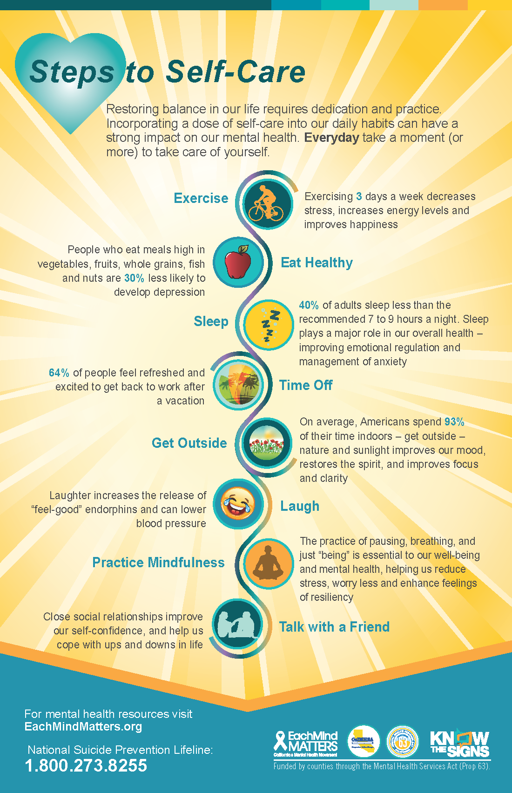
Visit the Each Mind Matters website for additional self-care tips and resources at https://www.eachmindmatters.org/spw2019/

