Restaurant & Service Industry - Social Media Guide / Guía para las Redes Sociales

ENGLISH
Facebook: It is officially #SuicidePreventionWeek2020 & #NationalRecovery Month! The Restaurant and Service Industry are no strangers to the effects of mental health and substance use. Let us use this time to join together to spark more conversations and end the silence about mental health and suicide prevention. Let us work together to cultivate a work environment that is a safe space to get help. To learn more information visit suicideispreventable.org

Instagram: It is officially #SuicidePreventionWeek2020 & #NationalRecovery Month! The Restaurant and Service Industry are no strangers to the effects of mental health and substance use. Let us use this time to join together to spark more conversations and end the silence about mental health and suicide prevention. Let us work together to cultivate a work environment that is a safe space to get help. #SuicidePreventionWeek2020 #EachMindMatters #NationalRecoveryMonth #KnowTheSigns #ReachOut #SaveALife #MentalHealth #SuicidePrevention #ThereIsHope

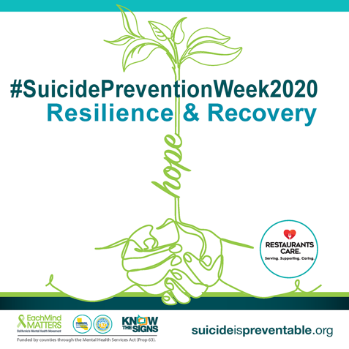

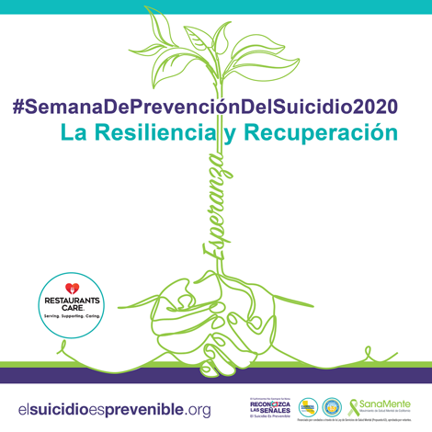
SPANISH
¡Es oficialmente la #SemanaDePrevenciónDelSuicidio2020 y #MeDeLaRecuperación! La hostelería no es ajena a los efectos de la salud mental y el consumo de sustancias. Aprovechemos este tiempo para unirnos a comenzar más conversaciones y acabar el silencio sobre la prevención del suicidio. Trabajemos juntos para cultivar un ambiente de trabajo que sea un espacio seguro para pedir ayuda. Para más información, visite elsuicidioesprevenible.org #SanaMente

ENGLISH
Facebook: All of us can play a role in suicide prevention. In honor of #SuicidePreventionWeek2020 we encourage you to visit suicideispreventable.org to learn more about the warning signs, how to have a conversation with someone you are concerned about, and to find helpful resources. Together we can know the signs, find the words and reach out.

Instagram: All of us can play a role in suicide prevention. In honor of #SuicidePreventionWeek2020 we encourage you to visit suicideispreventable.org to learn more about the warning signs, how to have a conversation with someone you are concerned about, and to find helpful resources. Together we can know the signs, find the words and reach out. . @EachMindMatters #SuicidePreventionWeek2020 #EachMindMatters #NationalRecoveryMonth #KnowTheSigns #ReachOut #SaveALife #MentalHealth #SuicidePrevention #ThereIsHope
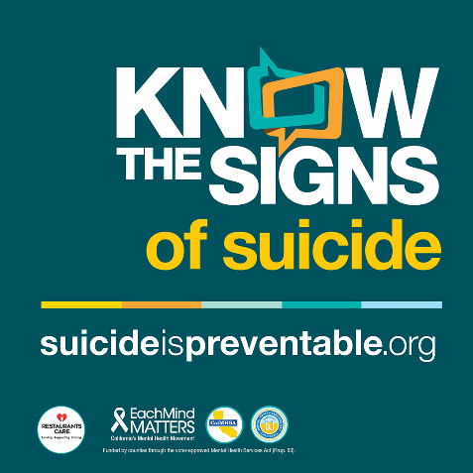

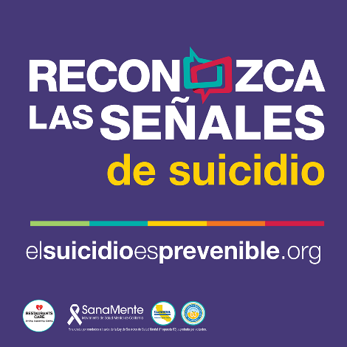
SPANISH
Todos podemos tener un función esencial en la prevención del suicidio. Para celebrar la #SemanaDePrevenciónDelSuicidio2020, los alentamos a visitar el sitio web elsuicidioesprevenible.org para más información sobre las señales de advertencia, cómo comenzar una conversación con un ser querido, y para recursos útiles. Juntos podemos reconocer las señales, escuchar y dialogar, y buscar ayuda. @SanaMente #SanaMente #ReconozcaLasSeñales

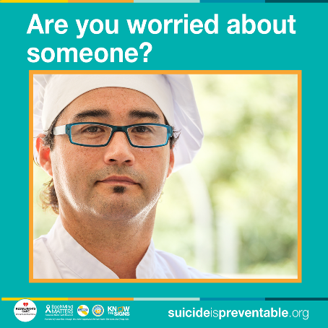
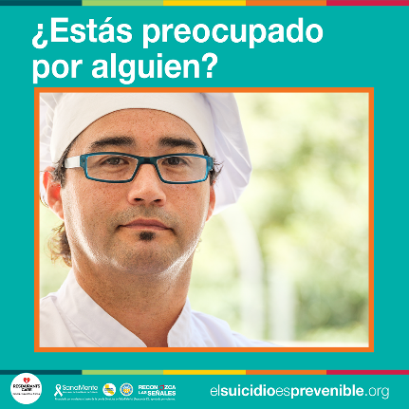
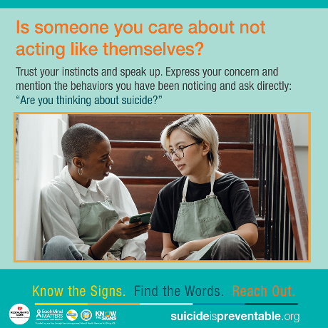
ENGLISH
Facebook: Is someone at work not acting like themselves? If you’re worried about a co-worker, the best thing that you can do is to trust your instincts and speak up! Mention the behaviors you have been noticing and ask directly if they are thinking about suicide. Saying the words directly, “Are you thinking about suicide?” can be difficult to say, but when it comes to suicide prevention, none are more important. And remember you are not alone. Call the National Suicide Prevention Lifeline at 1-800-273-8255 if you are concerned about a loved one or in crisis yourself. To learn more about the warning signs for suicide and tips to start a conversation with someone you are concerned about visit suicideispreventable.org @EachMindMatters #SuicidePreventionWeek2020 #EachMindMatters #KnowTheSigns #SpeakUp #YouAreNotAlone #MentalHealth #SuicidePrevention #ThereIsHope

Instagram: Is someone at work not acting like themselves? If you’re worried about a co-worker, the best thing that you can do is to trust your instincts and speak up! Mention the behaviors you have been noticing and ask directly if they are thinking about suicide. Saying the words directly, “Are you thinking about suicide?” can be difficult to say, but when it comes to suicide prevention, none are more important. And remember you are not alone. Call the National Suicide Prevention Lifeline at 1-800-273-8255 if you are concerned about a loved one or in crisis yourself. To learn more about the warning signs for suicide and tips to start a conversation with someone you are concerned about visit suicideispreventable.org @EachMindMatters #SuicidePreventionWeek2020 #EachMindMatters #KnowTheSigns #SpeakUp #YouAreNotAlone #MentalHealth #SuicidePrevention
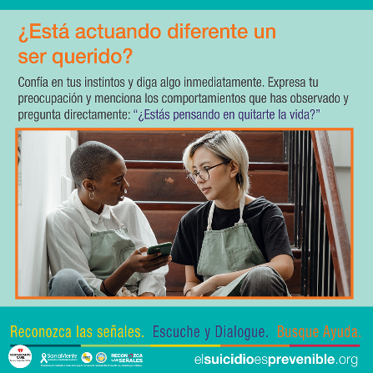
SPANISH
¿Está actuando diferente alguien en el trabajo? Si estás preocupado por un compañero del trabajo, ¡lo mejor que puedes hacer es confiar en tus instintos y di algo! Menciona los comportamientos que has observado y pregunta directamente si están pensando en suicidarse. Preguntando directamente, “¿Estás pensando en quitarte la vida?” puede ser difícil, pero cuando se trata de la prevención del suicidio, nada es más importante. Y recuerde que no estás solo. Llame al Red Nacional de la Prevención del Suicidio al 1-888-628-9454 si estás preocupado por un ser querido o si estás pasando por una crisis emocional. Para más información sobre las señales de advertencia y sugerencias para comenzar una conversación con alguien de quien estás preocupado, visite elsuicidioesprevenible.org #SanaMente

