SanaMente
Qualitative Research Project
January 2016

Prepared by Poza Consulting Services
For Runyon Saltzman Einhorn
On behalf of California Mental Health Services Authority

SUMMARY
The purpose of this study was to identify gaps in Latino-specific resources and needs, as well as to help assess efficacy of the interim website developed for SanaMente, the Spanish language version of Each Mind Matters: California’s Mental Health Movement, an initiative charged with reducing stigma and discrimination surrounding mental health challenges and preventing suicide.
A series of focus groups and key informant interviews were performed with mental health professionals, Promotores and lay people from counties throughout California with an emphasis in Southern California given that Los Angeles County alone has a Latino population of 48 percent, almost 10 percent more than the state average (U.S. Census Bureau). Aside from reviewing the website, respondents were asked questions to gain insight on current general awareness and understanding of mental health issues among the Spanish dominant and indigenous Latinos in California.
Findings suggest that the SanaMente movement is very much in its initial stages in that relatively few have even heard of SanaMente or have even a basic understanding of mental health issues. SanaMente’s goal to help alter the perceptions of mental illness in the Latino community that lead to stigma, discrimination and isolation of individuals dealing with mental health issues) Fear and misinformation prevail with the majority of Spanish dominant and Mixtec/Zapotec dominant Latinos (two of several indigenous Latino groups present in California) believing those suffering from mental illness are “crazy”, “weak” and possibly responsible for their condition. And while the website is a potentially important resource, for now the fear and stigma of anything associated with mental health keeps most Spanish dominant and non-English dominant indigenous Latinos from being willing to access it or related materials directly. Based on interviews, a recommended next step is to engage Promotores to introduce, inform and involve these populations in a conversation about mental health with the website and print materials serving primarily as resources for their work. Review of the website suggests that the current design is not sufficiently engaging yet, with some revisions, has potential to serve as a stand-alone resource.
This report provides detailed findings from this study, as well as specific recommendations on how to improve the website and how SanaMente can be most effectively leveraged to help combat stigma and discrimination of mental illness among Spanish dominant and non-English dominant indigenous Latinos in California.

Background and Objectives
The voter-approved Mental Health Services Act (Prop. 63) funds three statewide projects under the prevention and early intervention (PEI) component that are being implemented by the California Mental Health Services Authority (CalMHSA), an organization of county governments working to improve mental health outcomes for individuals, families and communities. The following statewide projects are developed under the banner of Each Mind Matters: California’s Mental Health Movement:
- Stigma and Discrimination Reduction
- Suicide Prevention
- Student Mental Health
SanaMente is the Spanish language version of Each Mind Matters. Its focus is to reach the Spanish dominant population in California with PEI information. Similar to Each Mind Matters, SanaMente’s goal is to “…put an end to this stigma, creating a community where everyone feels comfortable reaching out for the support they deserve” (as noted on eachmindmatters.org). Latinos are the largest ethnic group in California with the overwhelming majority (82%) being of Mexican descent, yet studies suggest this population is underserved when it comes to receiving mental health services. A study by Vega, Kolody, Aguilar-Gaxiola, Alderete, Catalano, and Caraveo-Anduaga (1998) reported only about one in four (27%) adult Latinos of Mexican-origin who had one or more mental disorders in the previous 12-months received any kind of service (this includes services provided by mental health providers, general medical providers, other professional providers including counselors and other informal providers). The problem of underutilization is even more accentuated in Mexican immigrants. According to the Mexican-American Prevalence and Services Survey (MAPSS), 85 percent of Mexican immigrants who needed services remained untreated (Vega, Kolody, Aguilar-Gaxiola, & Catalano, 1999). This pronounced underutilization of mental health services is even more pronounced among Mexican migrant agricultural workers (only 9 percent of those who need mental health services use services). Research has repeatedly shown that this population receives no care unless they are extremely dysfunctional or a danger to themselves or others (Vega, Kolody, Aguilar-Gaxiola et al., 2001). SanaMente aims to be the unifying voice for all Latinos in California and provide a platform for those who wish to speak openly and honestly or seek out services, and have the opportunity to do so without fear of judgment or discrimination.
CalMHSA’s Stigma and Discrimination (SDR) social marketing contractor, Runyon Saltzman Einhorn (RSE), was tasked to identify ways to leverage SanaMente to address the stigma around mental health in the Latino community and motivate and mobilize community members to join California’s Mental Health Movement. As part of this effort RSE has created a number of prevention and early intervention materials including the recently developed fotonovela series – a set of three visual stories in Spanish and English each with its own storyline intended to increase awareness of mental health challenges and the stigma often associated with them offering expert advice, tips, and games to engage the entire family.
In addition, RSE has created an interim Spanish language website – SanaMente.org – utilizing content that existed on the previous Each Mind Matters website, making that web content easier to locate as well as developing ways to drive traffic to the new, in-language site. Other SanaMente branded outreach material created so far includes a sticker informing the community of the movement in Spanish and in-language video vignettes of individual’s personal experiences of hope and recovery with mental illness. In addition, campaigns under the SanaMente umbrella include, Know the Signs (El Suicidio es Prevenible) that educates Californians to recognize the warning signs of suicide and Walk In Our Shoes (Ponte En Mis Zapatos) targeting 9-13 year olds to fill key gaps in knowledge that can lead to stigmatizing behaviors.
Before moving forward with further development of SanaMente resources, RSE commissioned this research
in order to:
- Evaluate the materials created thus far, and
- Gain a better understanding of current attitudes among Spanish dominant and indigenous Latino peoples regarding mental health
To this end, RSE contracted Poza Consulting Services to conduct a series of key informant interviews with mental health professionals throughout California as well as focus groups with:
- Community health workers (Promotores) who work with the Spanish dominant and
indigenous Latino population
- Spanish dominant lay people (i.e., no professional training, experience or knowledge
of mental health)
In terms of the scope of this project, although the CalMHSA mandate focuses on creation of materials to
reach Spanish dominant Latinos, given indigenous Latino peoples from Mexico are part of the overall California Latino population, this study was deemed a good opportunity to determine the extent to which these materials can be developed to serve them as well.
In addition to informing further development of the SanaMente.org website, information gleaned from this
study could help identify other culturally and linguistically relevant resources and strategies that need to
be developed to better engage these populations to create mental-health-friendly resources targeted to
these communities.
The specific objectives of the key informant interviews and focus groups was to:
- Obtain an increased understanding of the current level of mental health literacy in the non-English speaking Latino community.
- Understand the nature and level of stigma and discrimination regarding mental illness as well as themes that need to be explored to effectively address reducing stigma.
- Address gaps in understanding of mental health issues and the role SanaMente can play in this.
- Identify leverage points for motivating individuals and organizations to play an active role.
- Identify potential early adopters in the movement and their respective roles.
- Establish the appropriate calls to action for this community.
- Determine whether the current website serves as a tool and identify ways in which it can
be enhanced.

Methodology and Procedure
- Ines Poza, Ph.D. of Poza Consulting Services conducted all key informant interviews and
focus groups.
- RSE interfaced to provide introductions and contact information for key informant interviews as well as organizing and coordinating logistics for focus groups.
- Olivia Celis, CalMHSA consultant, gathered interest from key informants in the Los Angeles area to participate in the one-on-one interviews.
- RSE reached out to CalMHSA ethnic services managers (ESM) regional leads to gauge interest to participate in key informant interviews
  - ESM’s representing two regions agreed to participate
  - Key informants were also given the opportunity to provide names to be interviewed. We received two additional names originally not on our list as well as the names of a group of Promotores that ultimately were interviewed as a focus group over the phone.
Key Informant Interviews
- A total of 13 interviews with key informants were conducted with mental health professionals from Los Angeles (7), San Mateo (3), Stanislaus (1), Sacramento (1) and Colusa (1) counties. (See Appendix for Key Informant Discussion Guide.)
- Interviews were scheduled according to respondents’ availability and ran from mid-May through mid-July, 2015.
- Participants were asked to call in to a conference call system (Accuconference) so that the conversation could be recorded. Prior to starting the interviews, all participants were made aware of recording.
- Conversations lasted from 30 minutes to over 1 hour.
- Participants were informed of confidentiality, namely that specific comments would not be tied
to specific individuals.
- Participants were not compensated for their participation as it was in line with their current organization’s work.
Focus Groups
A total of five focus groups were conducted as follows:

County | Date | Type of Group | Number of Participants
San Bernardino | 5/27/15 | Promotores | 12
Orange County | 6/4/15 | Lay support group | 3
Los Angeles | 6/11/15 | Lay, diabetic support group | 12
Ventura | 6/30/15 | Promotores | 15
Stanislaus | 7/14/15 | Promotores | 3

- With the exception of the Stanislaus County group, all groups were conducted in person.
- Due to budget and logistical constraints, the Stanislaus group was conducted using Accuconference, the same method used to conduct the key informant interviews.
- Groups lasted two hours, with the exception of the conference call group with Stanislaus Promotores that lasted 90 minutes.
- Participants were recruited by identifying groups of people who already routinely met (as with the support group for diabetics).
- All groups were conducted in Spanish. Of note, although the Promotores group that took place in Oxnard was conducted in Spanish, these paraprofessionals work with the indigenous community prevalent in that area, most of which do not speak Spanish but rather their native tongue of Mixteco or Zapoteco.
  - This focus group was included to help represent the over 200,000 Latinos from about 60 indigenous groups from Mexico.
- Groups were video or audio taped or not recorded at all, depending on comfort level of attendees.
  - RSE worked with organization’s coordinator to get verbal consent from participants
- Breakfast or lunch was provided by RSE, as well as a $50 Visa gift card and SanaMente branded materials for each participant.

Findings: Part 1
stigma and Factors that Perpetuate it
Mental Health Literacy among Spanish Dominant and
indigenous Latinos
Mental health professionals and paraprofessionals (Promotores) interviewed agree the vast majority of
non-English speaking Latinos have little to no understanding of mental health issues. Key informants say
those who do have some understanding are typically those who have had to confront a mental health issue themselves, or on behalf of a loved one, and have educated themselves in the process. For most there is fear, denial and rationalization when it comes to thinking about mental health problems. This appeared to be the case with the lay groups conducted as many were unaware of mental health challenges and relevant methods of treatment.
Limited/Negative Vocabulary Associated with Mental Health and the Culture of Fear and Denial
Very few among the lay group could name specific types of mental illnesses (e.g., depression, schizophrenia). Instead, the two words that came up were, “nervios” and “loco.” Key informants and Promotores say this is consistent with their experience in dealing with Spanish dominant and Indigenous peoples from Mexico.
The following definitions are based on descriptions and use of the above-mentioned terms by focus group participants:
Nervios or “nerves” is the most common term lay people use to describe emotional problems. This covers a wide variety of symptoms ranging from emotional distress and milder forms of acting out (crying, fits of temper) to physical symptoms associated with depression and anxiety (e.g., trouble sleeping, loss of appetite). When applied ubiquitously as it usually is, it serves to minimize or otherwise dismiss more serious conditions like mood disorders or psychosis.
Loco or “crazy” is typically used to describe the kind of behavior that draws attention from law enforcement or is otherwise extremely disruptive (e.g., the person is a danger to themselves or
to others or causes public scenes or disturbances with floridly psychotic behavior).
The lack of information regarding mental illness and what it entails in turn drives fear and denial, which can ultimately lead to resistance in seeking services.

“As long as [people] can refer to a mental health problem as ‘nervios’ or ‘growing pains’ they can write it off as normal. Something they can get over on their own. …but if someone is diagnosed with some kind of mental illness, [people] immediately [assume they are] ‘crazy’. There’s no in between…and that’s scary for these people.” –Key Informant
Just the mention of “mental,” even in the context of “mental health” takes people to a negative place.

As an opening question with the lay group when asked,
“What comes to mind when you hear the term ‘Salud Mental’ (mental health)?”
The answer was “Loco.”
“I told my wife someone was coming to talk to the group today
about mental health. I asked her if she wanted to come and she said,
‘YOU go! I’M not crazy!’” –Member of diabetic lay group
Lack of Information and Misinformation
There were a few people in the lay groups who could name specific mental health conditions, including depression, anxiety and schizophrenia. This is because of personal experience dealing with family members who had been diagnosed. Because of this they had a somewhat more nuanced understanding of mental illness, (“Just because you are suffering from depression or anxiety doesn’t mean you’re crazy”). However, even the individuals who could come up with words other than “nervios” or “loco” had fears stemming from a lack of understanding about mental illness, asking questions like:

“If you stay depressed or anxious for a long time, will you become schizophrenic?”
–Member of diabetic lay group
Key informants and Promotores say this is not unusual. According to them, there is virtually no understanding of what mental illness is about and therefore a lot of fear about imagined consequences of being mentally ill.

“(People think if someone is diagnosed with a mental illness) it means they are going
to end up talking to the walls or like the homeless people – ‘los locos’ – they see wandering the streets.” –Promotor
“Immigrants think people with schizophrenia or bipolar are dangerous, that they’re mentally weak and that’s it. They’re like that for life.” –Promotor
“People are even afraid (mental illness) is contagious. No kidding. There is so much fear.”
–Promotor
For some Promotores, a lot of the work they do is with women who have suffered domestic abuse, helping them recognize the psychological toll it has taken and providing support. Because these women traditionally do not talk about their domestic situation let alone how they feel, they do not realize that their circumstances are not normal or something to endure and that the psychological pain they’re experiencing has a name and can be treated.

“They think that because they are not being hit, they are not being abused, but domestic violence is verbal, economic and behavioral… when a woman is prohibited from going
out of the home or only given $10 to take care of her needs. There is a lot of stress and depression.” –Promotor
“They come in for help for their kids and then once we start talking, they realize they need help too.” –Promotor
Mixtec and Zapotec Promotores working in Ventura County say indigenous people come from even more humble backgrounds than the average Spanish-speaking immigrant. They say as a result they are less sophisticated in their understanding and approach to physical conditions, let alone mental health.

“In our villages if you had a problem you went to a Curandero. There was nothing else. If we were lucky, a doctor MIGHT come through once a month to do the most basic things, set bones, give some medicines, but there was nothing… We didn’t know about mental illness… But what we are learning, we’re passing on.” –Promotor
Stigma Surrounding Mental Illness
As discussed, there is a considerable gap between what can be written off as “nervios,” and the kinds of psychotic behaviors most associate with “loco.” As a consequence, people whose behavior falls in that gap – those who are struggling to function at work and at home - are often labeled as weak, lazy, irresponsible
or otherwise somehow to blame.

“There are some people who think maybe the person has been cursed for some reason…
that [they asked for it] somehow.” –Promotor
Promotores from Stanislaus County said the lack of understanding regarding the genesis of mental illness contributes to stigma.

“…there are people who [believe] if you’re from a certain town or of certain social standing, that’s why you are mentally ill.“ –Promotor
If a child is facing mental health challenges, key informants and Promotores said family and friends tend to blame the parents for one reason or another.

“(Family members) will tell them, ‘You can’t get your kid to listen to you!’
which just puts more blame and shame on (the parents).” –Key Informant
“… A husband can say his wife is ‘débil de la mente’ (mentally weak) and
say this is why their child is autistic.” –Promotor
Cultural Differences between Spanish Dominant and Indigenous Latinos of Mexican Origin
According to Promotores who work with the Mixtec and Zapotec populations in Ventura County, indigenous peoples are even more reticent than the average Spanish dominant Latino when it comes to discussing emotional problems they may be experiencing. Many do not consider it appropriate to discuss personal problems even with those close to them.

“… There is concern they will look weak if they talk about how they feel. …For (indigenous peoples), talking about mental health is not just difficult. It’s taboo.”
–Promotor

Perceived Changes in THE PRESENCE of Stigma Over the Years
The majority of key informants and Promotores said they believe that while the stigma surrounding mental health issues has not gotten worse, it has not improved either. However, several think that while there is a
long way to go, things have improved. This is attributed to two factors:
- Individuals who have received mental health services for themselves or a family member, had positive experiences and as a result became advocates themselves. (About one quarter of the Promotores interviewed became Promotores for this reason.)
- Health organizations are employing the services of Promotores as cultural brokers to do outreach and education in the Latino communities about mental health issues.
Stigma and Families
As mentioned earlier, whether affecting an adult or child, mental illness is typically considered embarrassing and otherwise indiscrete to discuss with others, even among family members.

“(Family and friends) don’t want to even bring it up in the first place. It’s worse than being worried about saying the wrong thing. Saying ANYTHING is considered to be ‘the wrong thing’ because they think bringing it up will cause more harm and pain.” –Key Informant
“If someone is physically sick or had something very sad happen to them, everyone knows what to do. … there’s no worry about it. But when [it is a mental illness] no one knows. They’re scared to even talk about it.” –Key Informant
Many key informants say that when someone is experiencing a mental health challenge, the family rather
than recognize this as psychological issue, only see that their loved one is struggling. They will often pull together to support them in traditional ways including giving advice, spending time with them, or offering material assistance. Thinking the problem may be physical, family or friends often also encourage the person experiencing a mental health challenge to see a physician. Unfortunately, these actions while well-meaning can be counterproductive.
“Support” That Promotes Denial
One key informant said (and others agreed) that many families deal with a member suffering with a
mental health challenge by becoming extremely tolerant of unusual behavior and adapting to it rather
than seeking help.

“….like Tío Fulanito (Uncle so-and-so) who won’t come out of his room. … They’ll be very tolerant and even … enabling … bringing him food … not really talking about it ... As long as
his behavior is not too much for them to handle, they’ll deal with it that way. …The problem is that while this is going on, Tío (Uncle) is still suffering. He’s still [self-confined] to that room.”
–Key Informant
Key informants say, for these families, admitting to the severity of the problem and seeking help would
mean facing the embarrassment of discussing the problem with others as well as judgment of others and
even themselves as weak or irresponsible.

Misinterpretation of the Symptoms of Mental Illness – “Advice” that Makes Things Worse
Family members often interpret symptoms of depression and anxiety (low energy, lack of interest or avoidance of certain activities, disruption of sleep or eating habits) as laziness or shirking responsibility. As a result, they may offer advice to help their loved one rally, not understanding the underlying problem. Unfortunately, this can make matters worse.

“One of the strengths of the traditional Latino family is how they support each other.
They can count on each other for advice and support. … Unfortunately, the kind of advice they’ll give when it comes to, say, someone having problems with depression or anxiety might be things like ‘be a man’, ‘cheer up’ or ‘get over it’, [not realizing] it’s not that easy.“
–Key Informant
“Instead of helping, they [make them feel] even worse. Weak, guilty, more frustrated, hopeless and even more depressed or anxious. And then they REALLY don’t want to talk
to anyone about it.” –Key Informant
Physician Visits as Impeding Rather than Facilitating Understanding of Mental Illness
As mentioned, seeking help from a physician is not an uncommon step for many dealing with mental
health challenges. If the physician recognizes the individual’s symptoms as possibly related to mental illness, and has appropriate referrals at hand, there is a chance the patient will be connected with mental health services. With this, they and potentially their families can begin to learn about mental health and debunk
the associated stigma.
According to many key informants interviewed, however, many primary care physicians (even those who suspect depression or anxiety) treat presenting symptoms with medication and do not refer out for comprehensive mental health services.

“… the problem is that then [the person or family seeking help] think ‘This can be cured with a pill. Nothing to it’, but the real problem goes untreated.” –Key Informant
Furthermore, if the physician does not refer out for comprehensive mental health services, given the stigma associated with being diagnosed with a mental health condition, the patient is not likely to be motivated to
seek these kinds of services on their own.
Access to Community Resources A Function of Relationship with the Family
According to key informants and Promotores, if an individual suffering from mental health challenges is meaningfully connected with a faith community, school or other community organization, there is a good chance that through that group they can find information about mental health and/or leads on the services they need. This, however is predicated on having a meaningful relationship with an organization that in turn has access to accurate information rather than unintentionally impeding access.
As described by key informants a “meaningful relationship” means…

“… having a tie or personal connection. … that they have a relationship with their faith leader… someone they feel they can talk to... If at school, that they talk with their child’s teacher or … attend school functions or workshops with people they trust and can talk to...”
–Key Informant
One Promotor mentioned (and several others agreed) that, unfortunately, even if the family has a good relationship with their faith leader, they can still actually impede access to information about mental health
and associated services.
“They go in to talk to the priest and tell him about their troubles and all the priest tells them is to pray to God. …Prayer is good but … it isn’t enough.” –Promotor
Crisis – What Drives Individuals to Seek Information and/or Services
Key informants and Promotores say that because of the stigma related to mental illness, most individuals and families will only seek help when they are in crisis. For example, when either their or a family member’s behavior is more than they can handle and/or law enforcement has become involved. In either case, this usually means the person facing mental health challenges is potentially a danger to themselves or others.
As a Promotor working with the Mixtec population explained, when things are allowed to reach crisis, at that point the individual may never get the services they need. He gave an example of a woman who was concerned about her husband because of extreme stress he was experiencing at work.

“She had talked to a Promotora and believed they could help him. She talked to him about it but this made him even angrier. … He was under so much stress but he wouldn’t talk about it... saying he wasn’t weak. She couldn’t convince him. …The sad thing is, he eventually landed in jail because of his aggressive behavior. This didn’t have to happen if he had gotten the support he needed.”
–Promotor
Barriers to Seeking Information and Services
Misinformation and Fear of Government Agencies
Because most of those suffering with mental health problems don’t seek help or information until a crisis occurs and since at that point law enforcement or Child Protective Services (CPS) may need to be involved, key informants say there is erroneous information circulating regarding seeking mental health services and intervention by CPS.

“I talked to a woman about her son who I thought may have ADHD encouraging her to at least talk to the school counselor… She said she wouldn’t because her sister-in-law told her if she tries to get help for him, [CPS] will come take him away from her… We had a very
long talk!”
–Key Informant
Many Spanish-dominant or indigenous Latino peoples may have immigration status concerns. For that reason they fear drawing attention from the government in any way, even approaching a county or state run mental health clinic.

“They’re worried that once they ask for help, they’ll have the government camped out in their front yard.” –Promotor
Cost, Language, Proximity and the Undeveloped Word-of-Mouth Network
Even after overcoming fears regarding stigma and potential government involvement, individuals and families can still be thwarted in their efforts to receive services because of:
- COST Clinics in their area may not offer sliding scale and/or do not accept certain kinds of insurance.
- LANGUAGE Lack of qualified professionals or interpreters to offer services in language (Spanish, indigenous language) in their area.
- PROXIMITY The closest clinic offering in-language services they can afford is so far away it becomes cost prohibitive.

“By the time they get there it’s taken practically the whole day. They have to miss work to make these appointments… and they can’t afford to do that.” –Key Informant
- NO “WORD-OF-MOUTH” NETWORK Possibly because of the stigma surrounding mental health issues, reticence to discuss or ask for services and relatively low usage, the word-of-mouth information network most Latinos rely on to navigate life in the U.S. does not appear to exist when it comes to mental health services.

“‘Where do I get a dress for my kid’s Quinceañera? I have a bad cold. I found a lump on my neck. I’m worried I might have cancer. Where do I go?’ The [Spanish dominant] Latino community knows where to go for these things. …they’ll even tell you what bus to take…
But there is no ‘network’ if you have mental health issues.” –Key Informant

“(By the time they are in crisis), it’s not even pro or con [mental health services] for some. It’s more like ‘Our lives are falling apart and I can’t access services. I don’t know where to go.’”
–Key Informant
Difficulty accessing services – an impediment to promoting trust in the mental health community
While the focus of this study is on identifying ways to positively impact public opinion regarding mental health, and the role SanaMente can play in this regard, at this nascent stage in the movement, difficulty in accessing services is important to consider in terms of the negative word-of-mouth it can potentially generate.
Key informants spontaneously identified this as a serious problem.

“The biggest stumbling block is [lack of] therapists who are genuinely fluent in Spanish and well versed enough in cultural nuance to be able to provide competent services. …the help isn’t there and then there goes the trust.” –Key Informant

“(Difficulty accessing in-language services is)… not only for people with serious mental illness, there are also not enough clinical services for prevention like support groups or out-reach with information using paraprofessionals… They’re the ones who are able to penetrate.”
–Key Informant

“In Mexico, people can go to pharmacists for a lot of things and he knows what medication to give them. It doesn’t require going to a doctor or needing health insurance or anything complicated. It’s a way of making things affordable and accessible. Letting a pharmacist handle the things they can handle. … There needs to be that kind of ad hoc service in mental health. Otherwise a lot of people… fall through the cracks. They lose hope and don't believe the [mental health] professionals.” –Key Informant

“I spent months working with a couple, encouraging them to get services… after so much work then they finally trust you and are willing and then find out there is an EIGHT month wait list because there are so few interpreters [for Mixteco]… they feel let down. … We can lose [their] trust.” –Promotor

Findings: Part 2

Combating STIGMA
The Need for Information
Based on information gleaned from key informants, Promotores and lay people participating in this study,
there are four main types of information that need to be addressed in order to dispel myths, reduce fears regarding mental health issues and normalize the topic of mental health. These topics include:
- Information regarding the nature of mental illness;
  - Not an issue of character (weakness, laziness, irresponsibility),
  - Not contagious,
  - Similar to medical conditions in terms of requiring treatment,
  - Depression and anxiety do not cause schizophrenia.
- Statistics on incidence of mental illness and percentage of those with positive prognosis that is possible if treated.
- Testimonials from those who have struggled with mental health issues, for themselves or family.
- Information regarding the limits of governmental involvement CPS or INS (Child Protective Services or Immigration and Naturalization Service) when making inquiries about mental
health services.
The SanaMente website currently includes information that addresses many of these issues. However, as explained in previous sections, people are not likely to access print or Internet-based information on their own.
Key informants and Promotores say in some instances illiteracy makes print useless, but mostly it is the stigma around mental health issues that keeps people from feeling comfortable accessing information on the topic in the first place.

“The website and pamphlets, all that material… they have to know about it, have someone like me talk to them about it before they check it out. Otherwise they won’t go near it.” –Promotor
The Power of Information through Conversation
As shared earlier in this report, “loco” was the word members of the lay focus groups said came to mind when they heard the term “mental health.” Not surprisingly at the beginning of one of these groups, one participant was particularly reticent to speak and was defensive when he did saying, “There’s nothing wrong with me.”
While the purpose of the group was not to discuss personal experiences with mental illness (see appendix for Focus Group Discussion Guide), in the course of discussion, 3 of the 12 participants went on to share personal struggles or those of family members with mental illness ranging from depression and anxiety to schizophrenia.

“I’ve struggled (with depression), I have and I know what it’s like. … (Now) people look to me for support. They come to me with their problems... I say ‘It’s good to talk about it!’”
–Lay person
“My (family member) was diagnosed with schizophrenia. … Everyone thinks that means your life is over…You’re crazy, but it’s not like that. She (gets treatment) and is doing well.”
–Lay person
As participants continued to share their experiences, the gentleman who was initially reticent began sharing stories about a nephew who appeared to be struggling with depression, his concern for him, his brother’s denial of the nephew’s struggle and his own attempts at helping him.
In reviewing the SanaMente website, along with other group members, he said the information on mental illness was new to him and made him think differently about mental health. After the group concluded, as the moderator was preparing to leave he approached her and said,
“I was a little bit worried about what today’s discussion was going to be about
but this was really interesting. When are you going to have another one of these?”
–Lay person
This kind of exchange is consistent with what Promotores say they experience in talking with the public. Despite fear and reticence to engage at the beginning of conversations, there is a desire to know more about mental health issues and a need talk about it, but this requires someone like a Promotor to break the “ice”, initiate a dialogue, and build some trust.

“We bring a lot of pamphlets but no one goes near them. … but when we do our presentation … we have like the symptoms (of depression) up on a slide and we talk about it, then afterwards people come up and start asking us questions about it and picking up the pamphlets... but it takes us bringing (the information) to them and talking about it … otherwise, they won’t touch it. ” –Promotor

“We can pass out 1,000 pamphlets, but most don’t know how to open a website. … It’s
when we sit down with them… because of all the training we've had and, our style, our way
of establishing rapport so that they feel trust…that’s when they open up.” –Promotor
Key informants and Promotores said that conversations about mental health with professionals or paraprofessionals are important because they can provide:
- Accurate information that helps dispel the myths and fears that feed stigma.
- A comfortable environment that allows people to relax enough to be open to receiving the information.
- The opportunity to experience talking about mental health as something “normal” which, in turn, helps normalize mental health issues in general.

“Once (people) hear someone else talk about their struggles (with mental illness) it helps normalize things. …They start to realize that first of all if it can happen to someone like that,
it can happen to anybody, and even more importantly, if they’re suffering, that they’re not alone.” –Key Informant
“Literally anything you can do to promote conversation, a dialogue…it helps normalize
(mental health issues).” –Key Informant
Ways to Promote Conversations about Mental Health
Key informants and Promotores shared a variety of ways to reach out to Spanish-dominant audiences and jump-start dialogue including:
- Radio or television programs where listeners/viewers can call in and ask questions,
- Learning modules and presentations in schools,
- Using popular local gathering places (e.g., shops, coffee houses) where early adopters can encourage conversation,
- Organized health/mental health festivals and community events that include celebrities, if possible,
- Leveraging Promotores;
  - Conducting workshops headlining topics that attract attendance (see below),
  - Equipping them with branded materials they can wear (T-shirts, buttons, etc.) or carry with them to engage others at flea markets, sporting events, festivals and in public in general.
Radio and Television
One key informant talked about a successful event that took place in Richmond, CA coordinated between
Familias Unidas (Richmond-based organization that provides mental health counseling, service advocacy, and information/referral services) and a local radio station. This key informant also mentioned a telethon that took place in Los Angeles, courtesy of Univision entitled “Una Vida Una Mente” (“One Life One Mind”). According to the key informant, the program ran from 2 to 11 p.m. and generated more than 500 calls.

“People were wanting to talk about (mental health)... A lot of questions… The calls were backed up… It really opens people’s minds.” –Key Informant
Another key informant said even short segments on a popular radio program would be excellent.

“Like ‘El Piolín por la mañana’… the radio is a big deal. So many people are listening. They’re working in the field. If the radio shows (on mental health) are available, they could be listening to these shows at work or in their cars. …when someone well known like El Piolín puts it on his show… it makes it okay to listen to it.” –Key Informant
Learning Modules Presented through Schools
Some key informants believe the best way to eradicate the stigma associated with mental health is to target children, saying the older generations may be too set in their ways to be meaningfully impacted.

“These campaigns need to start with the little ones. Like the anti-smoking campaigns or even anti-littering campaigns way back.” –Key Informant
Other key informants and Promotores say that doing presentations at schools for children not only helps
shape children’s thinking on mental health, but also opens the door to impacting their parents. Children
bring information home and share with others.

“Kids get excited about what they learned at school. They run home and talk about it with their family. … The way a lot of these (Spanish-dominant) homes are, they almost rely on the kids to serve this function. … this is how some families learned about the importance of diet and preventing illness.” –Key Informant
Identifying Local Gathering Places
According to key informants and Promotores, part of the challenge to engage people in dialogue is overcoming their fears about the subject. One of the best ways to do this is to meet people in non-threatening contexts like places where they routinely spend time, have fun or seek information they need.
One key informant said he was challenged with spreading information about health topics of an intimate nature and is particularly difficult for the Spanish-language-dominant community to discuss. He enlisted the help of a local business, a popular hair salon, in making pamphlets available for patrons.

“It was a popular place where the ladies all go and talk and share … the owner is a very friendly lady who was very interested in (health topics) very much into it so would talk to people who came in about the (materials)… they trust her, they like her and talking with her… getting the conversation going in the first place normalizes it. This needs to happen.” –Key Informant

“We go out to not just schools but different meeting places where we feel we’ll be meeting
all members of the community. It’s a good chance to open things up for any questions.”
–Promotor

”Curiosity and interest in mental health issues comes out naturally once a relationship has been established… (Outreach at events) is not about pushing but rather leaving a space open for people to step in. Engaging people so they can learn and help each other.”
–Key Informant
Another key informant suggested local grocery stores, WIC offices, and even bingo games as possible
venues explaining,

“If you reach out in places they trust and with people they know, that’s half the battle.
…Or like at a bingo game, fun things… it promotes a feeling of belonging and inclusion
when it comes to (mental health) instead of fear and avoidance.” –Key Informant
Organized Mental Health Festivals and Events
“Caminatas” (Organized Walks)
The Promotores from Stanislaus were energized and excited about the recent NAMI (National Alliance on
Mental Illness) walk they participated in on May 30, 2015 in San Francisco. They believe this kind of event in
their community, specifically for the Spanish-language-dominant community would be an excellent way to attract people, increase awareness, encourage conversations about mental health, and network. They also feel the proud and joyful nature of the walk can help normalize the topic of mental illness and combat stigma.

“It was incredible. To have people marching together, holding signs up saying ‘NO to Stigma!’ right there in the open. A great thing to walk proudly holding these (signs), inviting people to join in, ask, talk about (mental health)… And for someone to walk in the street with a t-shirt and sign right out in front… it makes it okay to talk about it.” –Promotor
“When we went to San Francisco it really impacted... it was a conference Tools For Change. It was great! The walk was just for attendees. … to see everyone in their (SanaMente) t-shirts, with signs, walking was wonderful.
“To have something like that HERE, una ‘Caminata’ in SPANISH! … Imagine! People would be asking about that green color (on the branded items and t-shirts)… it’s a great color for this, really attention getting…If we bring cases of free water, snacks… people get interested.”
“Oh! And May is Mental Health Awareness Month! Think of all the people we could get together at the county level! And hey! Cinco de Mayo is right then and Mother’s Day comes smack in the middle of it! …There would be lots of (interesting, fun) things we could make part of this.”

“Sana Sana Colita de Rana, Care for Yourself Today for a Better Tomorrow” –
Event in South San Francisco
A key informant from the Bay Area referenced this event – the 2nd annual Latino health forum sponsored
by the San Mateo County Latino Collaborative and the Healthy Weight Collaborative – which took place on September 20, 2014 saying there was a surprisingly good turnout. Aside from kiosks and availability of Promotores and other professionals to provide information to the public, the key informant credits the
inclusion of celebrities in drawing crowds, including Kira Vilanova, local anchor of Univision’s “Al Despertar”
as keynote speaker.
“They don’t even have to be nationally known. Even the local news anchors on Spanish television. … People want to see them.” –Key Informant
More than just drawing an audience, the key informant said the celebrity’s opinion appears to carry weight.
“I remember Flavio Lacayo (from the September 2013 event) said to the crowd, ‘I’m sorry I have to go. I wish you could stay for the whole event.’ And they stayed!” –Key Informant
Key informants and Promotores agree that celebrity spokespeople are important, not only in drawing attention, but in normalizing the topic of mental health and encouraging dialogue.
“If (a celebrity) is talking about it, it must be okay. ...Especially if they’ve had challenges with mental health issues…It shows, ‘I’m just like you’.” –Key Informant
Leveraging Promotores
Along with stigma surrounding mental health, Promotores say there is also a good amount of fear and mistrust regarding mental health providers and the treatment process in general. According to a Promotor, some providers unwittingly contribute to this, not realizing the importance of extending warmth and kindness to first time Latino clients who do not speak English. She explained that cold, clinical treatment feels dehumanizing and disrespectful, further promoting distrust of the process. One such client refused to return to therapy telling the Promotor about the therapist, “Ni los ‘buenos días’ me dió!” (“He didn’t even greet me!”).
Because they understand the mindset and sensibilities of the Spanish dominant and indigenous Latino people they work with, Promotores are able to fine tune their approach to this population and provide a much-needed bridge for them in understanding and accessing information and services about mental health. In this way, Promotores are an invaluable resource in combatting the stigma of mental illness.
“Somos el Puente” (“We are the Bridge”)
At this point in the SanaMente movement where a dialogue is necessary for people to overcome their
initial fears of the topic, Promotores may be the most effective way of reaching the community. As a
Promotor explained,

“(Because of the fear the topic arouses), we have to use a soft approach. … We receive [people] with a hug. We talk about informing them not educating them. We say, ‘What I’m learning, I pass along’… They relax and start to feel comfortable…We are the bridge.”
–Promotor
“… I feel people are [now] a little more open to hearing about what therapy and psychologists are all about. But the trust we’ve been able to achieve is by entering very, very carefully. Connecting carefully and gently. Not a lot of questions. … Not feeling judged [by us].”
–Promotor
As a Promotor working with the Mixteco Project commented, the desire and need for more information regarding mental health issues is definitely there, however fear and often practical limitations such as illiteracy stands in the way of people accessing it on their own. He claims Promotores are a vital link in bringing information to this population.

“People don’t want to continue suffering, but until someone shows them the way, they will keep going the way they are.” - Promotor
Mental Health Modules Embedded in Informational Workshops
Promotores say that workshops are an efficient way of connecting with people as opposed to one-on-one, reporting high turnout for topics including:
- Immigration
- Dealing with the police
- Housing
When it comes to mental health however, the very need for conducting workshops on this topic is the reason
they are often not well attended, namely, stigma and fear keeps people away.
Promotores working with the Mixteco Project said one way of reaching people could be by including a
mental health module in with other topics to at least introduce and open discussion on mental health and
build from there.

“Once they’re there, they’ll listen” –Promotor
Using Branded Materials to Engage and Inform when Out and About
According to Promotores and some key informants, soccer games or other local sporting events are a
great place to interact with the Latino community. While there isn’t much opportunity for long conversations, Promotores say that while they walk through the crowds wearing a SanaMente t-shirt and carrying branded materials, it prompts people to ask and a conversation begins.

“The other day (a Promotora) was at the supermarket, wearing a green ribbon and the woman next to her asked what it was for so she started telling her about SanaMente. …As it turned out that lady had a lot of problems… Having the ribbons and hats or bracelets, people ask and (the skill we have in establishing rapport) we’re able to talk with them.” –Promotor
“It really opens the conversation. ‘¿De qué es ese moñito?’ (What’s that little ribbon about?) and the chat takes off.” –Promotor
Reaching and Identifying Early Adopters
Children/Youth
As mentioned before, either out of concern that older generations are too hard to reach or because they can
serve as a conduit through which to reach the older generations, Promotores and key informants alike agree that children are excellent targets as early adopters.

“They learn these lessons early and they carry it forward with them.” –Promotor

“There are enough kids with IEPs (independent education plans) because they are struggling with emotional issues, depression, anxiety, there in the schools. … It’s a ‘teachable moment’ as it were… acceptance and understanding.” –Key Informant
In terms of how to reach this target age group, aside from learning modules in schools, one key informant recommended leveraging social media and popular events, “… tied to the English-speaking world they live in.”

“Website is dinosaur modality. Social media is more dynamic. If (the message) can be tied to Twitter or Facebook or other more popular social media, that could help.”
“If you tie the message into benefit concerts for a cause they are aware of in the English-speaking world they move in, that’s a good way to draw attention. If there are any pop stars they’re interested in, mainstream or Latino, who can talk about it to get them interested in it and, in turn, tie it into relevant social media associated with these stars, they follow.”
–Key Informant
Those in Recovery or Family of those in Recovery
Promotores and key informants also agree that many of those who go on to become advocates for mental health services – many becoming Promotores themselves – are those who have received services for themselves or a loved one.
“I struggled… it was a long time ago and things are better, but I had to fight hard, (I had to) struggle (to find services) for my son… I want to work so that others don’t have to go through that.” –Promotor
“The best people to move things forward (combating stigma) are families and individuals who have been impacted by mental health issues. It’s really about the passion brought in by people in recovery… those who have been through it.” –Promotor
Effectively Leveraging SanaMente
The Website – A Tool for Promotores and Potential Resource for the Community
The salient thread through interviews with Promotores, key informants and lay members of the Spanish-language-dominant community is the need for person-to-person exchanges and open dialogue regarding mental health issues. At this point, the level of stigma surrounding the topic of mental health is so high, just the idea of accessing information on the topic evokes fear. People are not willing to do this without an introduction or more personal encouragement. As such, the primary tool developed so far by CalMHSA to combat stigma in the Latino community, SanaMente.org, should not be considered a stand-alone resource. For the same reason, other materials developed so far (fotonovelas, stickers and magnets intended to drive traffic to the website) also do not function as stand-alone resources.
Key informants and Promotores say at this point these materials serve more as tools for them in working with the community. In the case of the website, Promotores see this as a potentially vital resource they can use, not only in making presentations, but to direct individuals to consult on their own and share with others once they’ve been able to engage them in the topic.
However, in reviewing the website in its current form, the prevailing opinion of the various respondents who participated in this study is that although it has relevant and important information it is not user-friendly for
lay audiences.

“Someone like me who is educated could totally understand this. Most people in our community are not educated, here or in Mexico.” –Promotor
“(The website) seems very high level. Not a high school level. Professional. It’s very nice, but seems more geared towards [a professional]” –Key Informant
“This is hard for me to sell to my community…It’s perfect Spanish but it’s not something that the community I work with would be able to use… too complicated, the verbiage.” –Promotor
“You really have to be college educated to get something out of it.” –Promotor
“Honestly, if I looked at this webpage on my own, I don’t think I’d click on anything… maybe ‘Historias’.” –Lay Respondent
Feedback on the Website
Overall, the color palette, images and general layout of the website are attractive and easy to understand in terms of functionality (e.g., click on tabs for access to different topics).
The information included is also considered relevant and important as far as targeting the fears and misunderstandings about mental health that feed stigma.
The way in which the information is delivered, however, is what appears to be problematic. The main issues in this regard include:

- Too much text throughout, especially in certain sections that are nearly all text,
- The grade level of language used throughout is considered by most key informants and Promotores to be beyond that of the average person in the communities in which they work,
- Not enough videos, images or alternate means of presenting information to make it engaging,
- Section names for the different categories of information that are off-putting, not engaging or
even misleading.
Following is feedback received related to each section of the SanaMente.org site regarding not only impressions, but suggestions on improvements that can make each individual section and the website overall a more powerful tool for Promotores as well as a more valuable and user friendly resource for Spanish-dominant and other non-English dominant members of the Latino community.
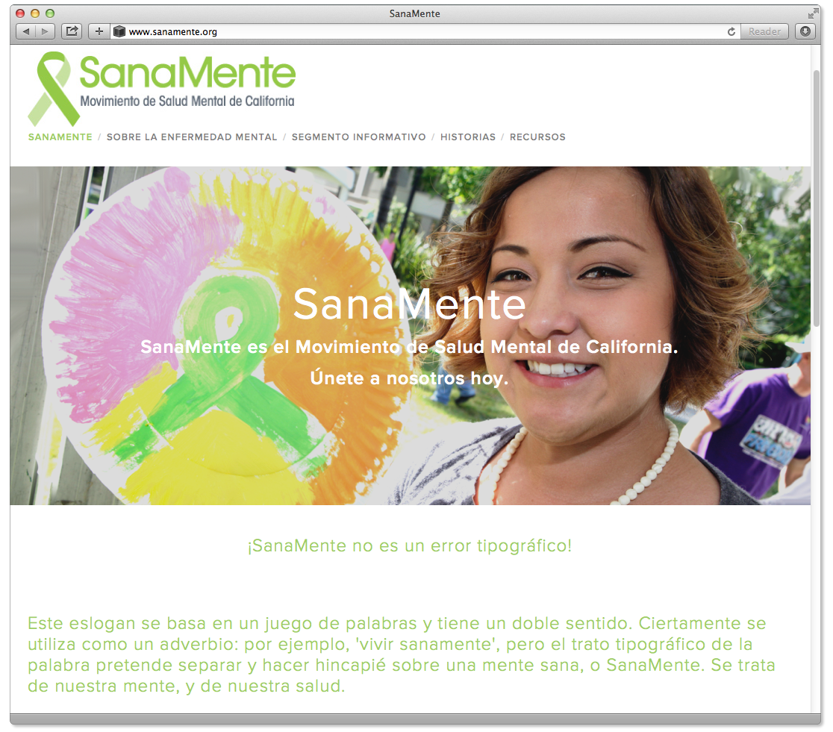
Homepage
Impressions
- The cover image is bright and attractive; uses a generally appealing color palette,
- The person pictured is relatable,
- Text featured immediately beneath picture is not engaging.

“Just the way it starts off, ‘SanaMente no es un error tipográfico’, I don't think (lay people) are even going to know what that means, or at least not really ‘get it.’ Right away it seems as though it’s directed to (a more sophisticated) audience.”
–Key Informant
Ways to Improve
Consider:
  - Adding music and art to the home page to make it more inviting and culturally relevant
  - Boosting brightness of the color palette using the fotonovelas as a guide
  - Employing a video (in Spanish and Mixteco) of someone explaining the information currently featured in text to provide more of a personal connection and introduction to the topic

“(At the home page) it’s less about the educational material and more about the need to make (the topic) come alive and engage people.” –Key Informant
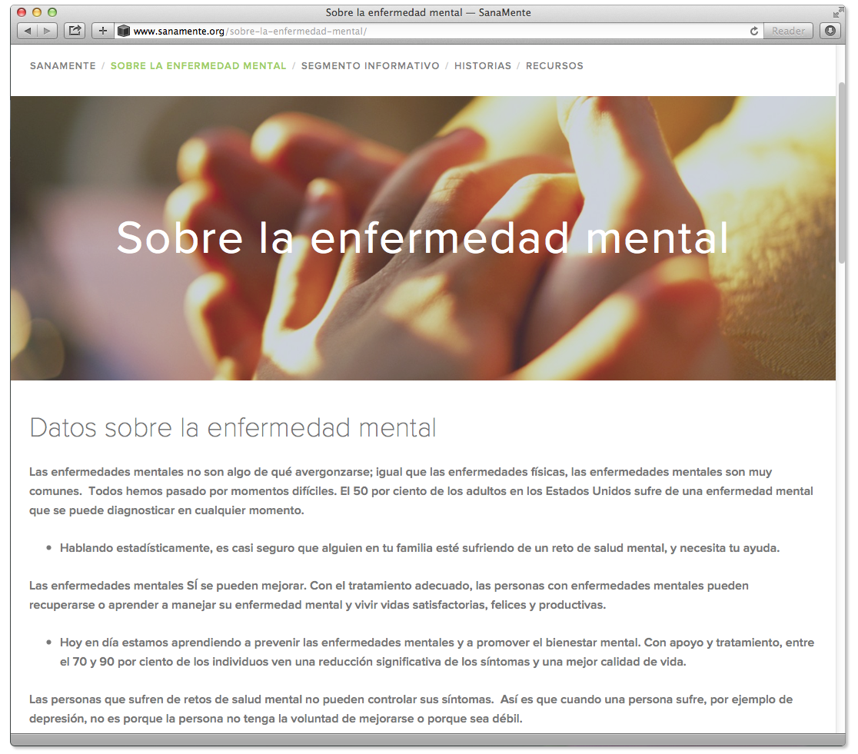
Sobre la Enfermedad Mental
Impressions
- The title itself while accurate is dry at best and intimidating at worst. According to some Promotores, “enfermedad” (illness) carries the connotation of something that could be contagious or even incurable with a prognosis of very poor quality of life if not terminal. In the context of mental illness, Promotores say the word “enfermedad” also implies “loco” which in turn suggests a life sentence of misery.
- The image featured (hands clasped) is not particularly compelling or relevant to the subject matter.
- All of the bulleted points are the kinds of information lay people interviewed not only found enlightening, but would also share with others.
- The information sheds light on commonly held misconceptions and gives a ray of hope in terms of possible prognosis if treatment is given.
- However, the format – a block of text with nothing to engage or illustrate – is off-putting to the point where many would not read in the first place.
- Most say they would never make it to the bottom of the page and see the “Para más información”
(For more information) section.
Ways to Improve
Consider:
  - Using words like “desorden” or “trastorno” (disorder) are more common vernacular and moreover suggest something temporary and/or treatable versus the word “enfermedad”.
Stanislaus Promotores said that physical illnesses like diabetes used to be viewed through a similar “life sentence” filter as mental illness.
“We had to learn that it (diabetes) was treatable, even to the point of not needing medication. It’s for life, but by taking your life by the reigns, you can live a good life. That’s how it is for someone with Schizophrenia. Bipolar too. By accessing treatment, people live good, full lives. … in explaining this to people, you need to use terminology that doesn’t make them lose hope. Words like ‘enfermedad’… better to use ‘trastorno’ or ‘desorden.’” –Promotor
  - Changing the section title to something like “Sabías Que…?” (Did you know?)
In line with what Promotoras in other areas have said regarding the importance of “informing” rather than “teaching” as a way to build rapport, Stanislaus Promotoras suggest abandoning the current title altogether in favor of something like, “Sabías Que…?” (“Did you know…?”).

“You see that title, ‘Sabías Que…?’ and you immediately start thinking, ‘What? What? I want to know!’ (laughs). It makes it approachable and more interesting in a non-threatening way… it’s a way in … to share information without sounding like you are about to be bored or scared.” –Promotor
Key informants, Promotores and lay people alike agree that rather than having this section dominated by text, the bullet points could serve as talking points in video clips of people – lay or professional – explaining each item. Aside from being more warm, inviting and engaging, this makes the information accessible to those who struggle with literacy. This is especially an issue within the Mixteco population. A video in Mixteco is especially important to this population as many do not speak Spanish. Leveraging video instead of text can increase the chances of people more fully exploring this page and finding “Para más información” section
  - Include content that helps promote hope and recovery such as mental wellness tips.

“This can include things that people want to do collectively. … taking walks… exercising… things that are meaningful to them and promote good mental health.” –Key Informant
This is in line with the Stanislaus Promotores’ idea to use words and ideas that encourage people
to “tomar las riendas” (take the reins), and understand that by doing so they can improve their
mental health.
Segmento Informativo
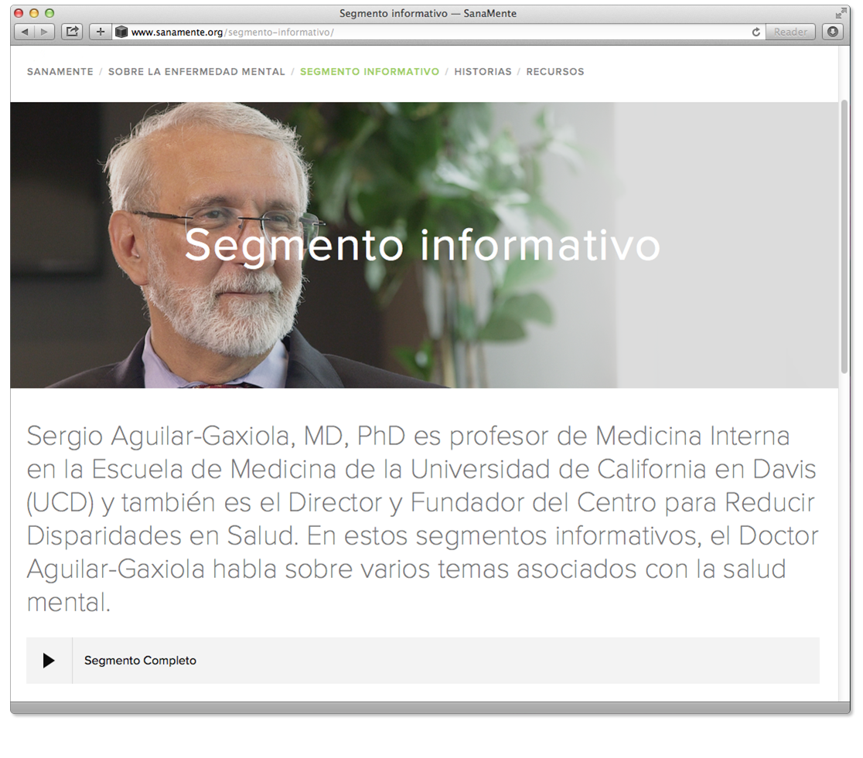
Impressions
- As with “Sobre la Enfermedad Mental”, although the title “Segmento Informativo” is accurate, it is not compelling to lay audiences.

“ ‘Segmento Informativo’ sounds very telenoticiero (like a news show)… but a boring one you wouldn’t want to watch.” –Promotor

- The idea of a section where experts (whether by training or experience) weigh in on different topics related to mental health is appealing. Several key informants said this is an area of the website that could introduce a variety of topics including:
  - LGBTQ issues;
  - Nuances of domestic abuse (e.g., not just battery but financial, emotional and social oppression);
  - Alcohol and substance use,
  - Identifying signs of psychosis;
  - Anger management; and
  - Identifying symptoms and signs of PTSD and other anxiety disorders.

“(SanaMente) could start archiving topics to build up a library, either in video or written form… best if it could be both… that in itself would be a great resource to have.” –Key Informant

- As for Dr. Aguilar-Gaxiola as a featured expert, although he is considered a great resource (known by most key informants), he is not leveraged to full advantage.
“(Dr. Aguilar-Gaxiola) is so warm and wonderful but here he’s reduced to sound bites.
...this format is too clinical and dry for (Latinos) at large to access.” –Key Informant

“Listening to him give you a lecture, the format doesn’t work. Who cares?” –Key Informant
Ways to Improve
Consider:
  - Changing the section title to something like, “El Experto Opina” (“The Expert’s Opinion”). Stanislaus Promotores say this will pique curiosity and promise interesting information.
  - Including a variety of experts from the ranks of professionals, paraprofessionals and people who have developed specific expertise dealing with mental health issues (e.g., learning how to talk to others about mental health issues).
  - Using this section to introduce people to the different types of mental health professionals and paraprofessionals that exist and what they do to help.

“Having clinicians, therapists presenting what they do to give people a little peek at what
these professionals are like… it helps break the ice and make people feel more comfortable.”
–Promotor

  - Featuring videos of experts talking directly to the camera rather than text or audio files.

“It’s much more engaging and interesting.
Otherwise it’s a lot to ask people to just listen or read.” –Key Informant
“Historias”
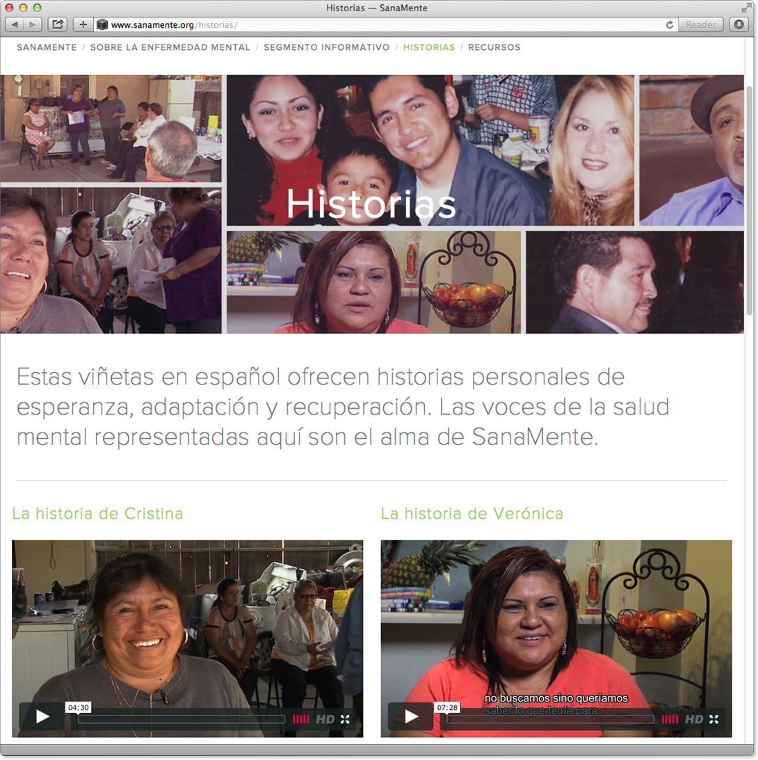
Impressions
- For lay people, this title was the most compelling from the
entire website.
- Respondents across interviews said this section suggests hearing from people willing to share their personal experiences.
- The images of the people featured were relatable.
- The videos themselves were interesting and compelling. A few had subtitles in English, which is considered a good idea.

“Some households are multi-generational where the younger ones don’t (speak Spanish) that well yet like to share resources with older (members of the family)…
Subtitles let’s them follow along.” –Key Informant
Ways to Improve
Consider:
  - Changing the section title to “Testimonios”.

“‘Testimonios’ sounds REAL… ‘Historias’ could be anything, perhaps made up stories.”
–Promotor
  - Including voice over in native languages (e.g., Zapoteco, Mixteco). According to Promotores working with this population, most are illiterate making subtitles or any written content of little to no practical use. If native language voice over could not be produced for all Testimonios, Promotores could provide input on which should have priority.
  - Including English subtitles on all videos.
Recursos
Impressions
- This section title suggests to most that it would feature links or information on where to access mental health services.

“There needs to be links. … If I’m going to go on this website it’s likely because (I need help) and to not find services will feel like a disappointment.” –Lay respondent

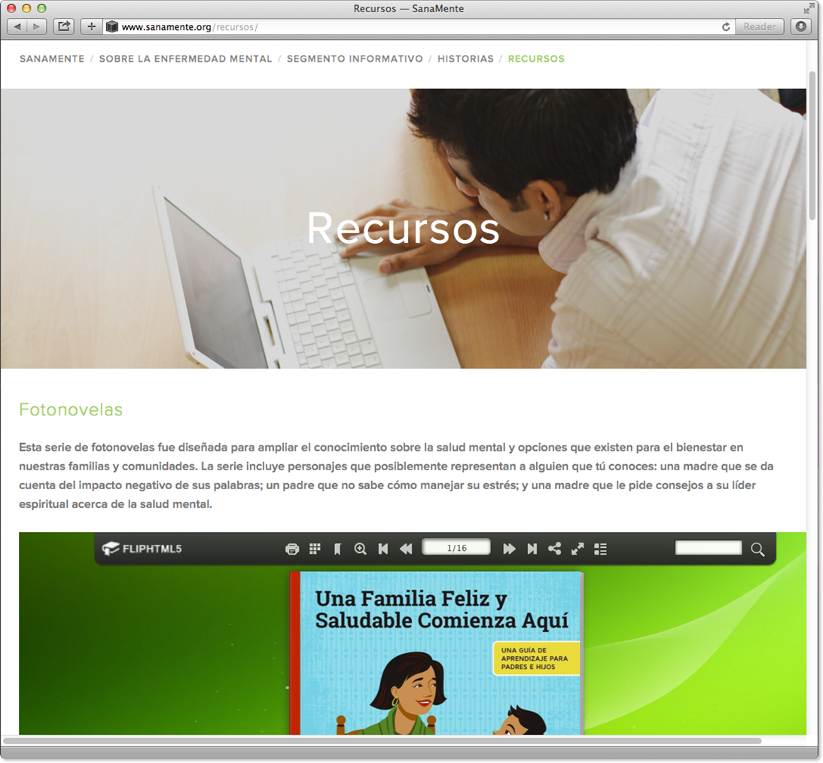
- The image (young man looking at a computer screen) is not particularly engaging or relevant to the topic.
- While many Promotores said they had used print versions of the fotonovelas featured in this section and found them useful, several key informants said they seemed to be too “text dense”, suggesting having it play out as a video would probably be more effective.
- The resource button for Disability Rights in California directs to a website in English that contains too much information to process and make sense of.
- When asked if this section (or any part of the website) suggests any kind of action to be taken, respondents across interviews said it did not. When asked if they thought members of the Latino community would be willing to take any kind of action, the majority of those interviewed agreed it would. In discussions with lay respondents, many said they would share information from the website with people they know, even on Facebook.
Ways to Improve
Consider:
  - Changing the section title to “Herramientas” (“Tools”).
  - Featuring a different image that is more evocative of tools/support.
  - Developing video fotonovelas to feature on website.
  - Including links to services, similar to those featured on the EachMindMatters.org site.
  - Directing links to Spanish-language sites.
  - Including a link to Facebook, giving options to ‘like’, ‘take a pledge to talk about mental health’ or otherwise post information from the website they think is interesting.
Developing Materials to Help Promotores Get the Conversation Going
According to Promotores involved in this study, the three main types of materials they find useful are:
- Information, facts and figures they can share in presentations.
- Pamphlets and informational fliers to distribute at presentations for people to refer to at their leisure and possibly share with others.
- Attractive, branded items they can wear and/or hand out at events or every day that draw people in and help get conversations started.
Presentation Materials
- Promotores say their job is to pass on what they learn. They believe the information included
in the website, particularly if modified as suggested in previous sections, is an excellent basis for
a presentation.

“We can serve as the bridge to give them that information… using the website and my computer with a projector, we can share it with others.” –Promotor
- The fotonovelas are also considered excellent take-aways. Several Promotores working with the Mixteco Project said they use them as the basis for workshops with children and adults.

“I used the fotonovela (featuring Roberto and his mother) with a group of children and it worked beautifully. … we had the group of children holding hands and making pledges about how to talk to each other….” –Promotor
SanaMente Branded Items
- Promotores say the branded items are a powerful means of attracting attention.

“When you carry these incentives, they really draw attention. People want to know what it’s about and that’s how we start talking.” –Promotor
- Aside from the green ribbons, pens, shoelaces, t-shirts and baseball caps, Stanislaus Promotores recommend developing green bandanas (pañuelos).

“That would be GREAT! We could have the girls who dance folklorico (at festivals) wear them around their waists or necks. That would really draw attention.”
“It’s such a great color people would ask what it’s about if you’re wearing it and that will start a conversation right there.”
–Promotor
- Other ideas for branded materials include:
  - Headbands/Sweatbands
  - Coffee cups
  - Water bottles or labels for bottles
“The (headbands, sweatbands and branded water) are perfect for caminatas (walks), it makes sense or … promoting physical activity… so important, good for your mental health… it’s a natural (connection)” –Promotor
- A non-essential but very attention-getting item suggested;
“And how about a pair of green Nikes for the Promotoras!” (laughs)
–Promotor
Attaching Celebrities to SanaMente
As discussed in previous sections, Promotores and key informants see celebrity spokespeople as a boon for the movement in terms of:
- Normalizing the topic of mental health (e.g., “If he has the courage to talk about it…”),
- Encouraging dialogue,
- Helping people facing challenges feel they are not alone.
While some argue it is more powerful if the celebrity chosen has personal experience with mental health issues, no one could think of a potential downside to using a celebrity to speak on behalf of SanaMente, whether they had personal experience with mental health challenges or not. Recommendations for appropriate celebrities include a broad definition of who is a celebrity:
- Local news anchors or radio personalities;
- Sports figures from all sports, not just soccer;
- Latino actors as well as mainstream celebrities that are more internationally known;
- Mainstream actors/celebrities known to Latino youth.

Recommendations
Findings from this study suggest that while there is interest and need of information regarding mental health issues, stigma and associated fears and even illiteracy in some cases prevents most Spanish-dominant and indigenous populations from being willing to access it directly through web or printed materials. Instead, information gleaned from this research suggests that at this point in the movement, resources need to be leveraged to engage this segment of the population in dialogue about the topic of mental health.
The following strategies (as outlined in Part 2 of this report) are recommended:
- Leverage Promotores for outreach and engagement to the greatest extent possible. Ways to do
this include:
  - Enlisting Promotores to identify popular local meeting places (e.g., shops, markets, community venues) as conduits for disseminating information - from resources to events - where they can learn more.
  - Developing and providing branded materials Promotores can wear and/or carry with
them for:
- Workshops and presentations,
- Sporting events,
- Local fairs, festivals, flea markets
- Mental health related events (e.g., “ Sana Sana Colita de Rana, Care for Yourself Today for a Better Tomorrow”),
- “Caminatas” (Walks) to raise awareness (e.g., NAMIwalk – walk for National Alliance on Mental Illness),
- When out and about in their daily lives. Many Promotores say they are willing to
engage in conversations about their work on an informal basis. They say branded
t-shirts and caps attract attention and often spur comments and questions that evolve into a conversation.
  - Developing mental health content that can be delivered as part of a workshop or presentation with a title that tends to draw attendance. For example, a presentation on how to deal with immigration, the police, health insurance or housing could also include a mental health module.
- Encourage recruitment of male Promotores
  - The majority of Promotores appear to be women. An argument can be made either way in terms of a man being more or less comfortable discussing sensitive issues with a member of the opposite sex. Some male Promotores from the Mixteco Project contend they understand the fears most men have about appearing weak and know how to discuss information “man-to-man.” For this reason, and at this point in the Movement, when outreach is very important, having male Promotores available could be a valuable resource.
- Aside from t-shirts, magnets, bracelets and other branded materials currently produced, expand items to include headbands, coffee cups and water bottles.
- Develop workshops and/or programs to share in local schools to enlist youth in the movement as early adopters. Promotores are eager and obvious allies to assist in carrying this activity out.
- Look for opportunities via social media to tie mental health messaging in to events or pop stars (Latino or mainstream) that are popular with young people.
- Consider means of recruiting among those who have successfully accessed mental health services on their own behalf or that of a family member or friend to join the movement.
- Use radio and TV to engage the public in a conversation about mental health rather than just as a means to disseminate information. This can be done in any number of ways such as approaching local program producers or even hosting a telethon in conjunction with a Spanish-language television station.
- In developing materials for outreach, organizing public events and in use of media, consider using celebrities whenever possible. Even local news anchors appear to be powerful in their ability to engage Spanish dominant Latinos as well as helping normalize the topic. Celebrity attachment to specific messages or media type should be carefully reviewed in order to make sure it is appropriate and most effectively utilized.
- Consider revisions to the SanaMente.org website as follows:
Home page
  - Add music and art to make more inviting and culturally relevant,
  - Boost brightness of the color palette using that used in the fotonovelas as a guide,
  - Insert a video (in Spanish and Mixteco) of someone explaining the information currently featured in text to provide more of a personal connection and introduction to the topic
“Sobre la Salud Mental”
  - Change title to “¿Sabías Que?”
  - Use the word “trastorno” or “desorden” instead of “enfermedad” (illness)
  - Incorporate video to communicate and help personalize as well as overcome literacy issues
for some accessing directly
  - Consider including wellness tips in this section
“Segmento Informativo”
  - Change title to “El Experto Opina…”
  - Use this segment as a place to build out information regarding mental health and related issues including:
- LGBTQ issues
- Nuances of domestic abuse (e.g., not just battery but financial, emotional and
social oppression)
- Alcohol and drug abuse
- Identifying symptoms and signs of psychosis
- Anger management
- Identifying symptoms and signs of PTSD and other anxiety disorders
- Emotional/social issues affecting youth
- Disability
- Homelessness
- Cultural diversity and tolerance issues
- Dealing with aging (dementia, disability, etc.)

  - Use this section to introduce people to the different types of mental health professionals and paraprofessionals that exist and what they do to help demystify what psychological services can entail
  - Include a variety of experts from professional (including Dr. Aguilar-Gaxiola), paraprofessional and even the ranks of lay people who have developed specific expertise dealing with mental health issues (e.g., learning how to talk to others about mental health issues, how to ask questions about mental health, etc.)
  - Include videos of experts talking directly to the camera to more fully leverage their presence (Dr. Aguilar-Gaxiola is underutilized in this respect) rather than text or audio files.

“Historias”
  - Change title to “Testimonios”
  - Include Mixteco/Zapoteco voice over tracks where possible
  - Include English subtitles where possible
“Recursos”
  - Change title to “Herramientas”
  - Feature a different cover image that is more evocative of tools/support
  - If possible, develop fotonovelas into videos to feature on the site
  - Include links to services similar to those featured on the EachMindMatters.org site
  - Make sure links to services take the user to Spanish-language sites as directly as possible
  - Include a link to Facebook, giving options to “like”, “Take a pledge to talk about mental health” or otherwise post information from the website they think is interesting

Appendix I: FOCUS GROUP DISCUSSIOn guide
Objectives
Gain understanding of:
- Perceptions and misperceptions regarding mental illness health and the fears and concerns regarding same
- Nature and level of stigma and discrimination regarding mental illness as well as the themes that need to be explored to effectively address reducing same.
- Information needed to address gaps in understanding of mental health issues and role SanaMente can play in this.
- Impression of SanaMente materials and website and extent to which they help individuals rethink/feel differently about mental health issues.
- Identification of leverage points that can motivate these people to play an active role.
  - Exploring appropriate ‘calls to action.’
  - Extent to which current website serves as a tool and ways in which it can be enhanced.
  - Ways in which messaging for Each Mind Matters could be adapted
Introductions – 10 min
PURPOSE: Explain ground rules for discussion and establish rapport.
Moderator begins with general guidelines for discussion including:
- Role of moderator – there to ask questions and find out “what people think and why.”
- Introductions of any other team members in attendance
- No right or wrong answers (“Favorite color” example)
- Importance of everyone participating in conversation and moderator’s role in making sure
all are heard
- Confidentiality of responses
- Moderator’s role in focusing conversation (important in making sure personal anecdotes to not dominate discussion and all topics can be covered).
- Audio/video taping (if applicable)
- Reference to any team members remote viewing
- Participants will be asked to give brief introduction including their name, family and work status and how they came to hear about the group.
General Context: Perceptions of Mental Illness – 20 min
PURPOSE: Gain understanding of baseline knowledge and attitudes about mental illness and assess personal relevance. Information will be used to interpret reactions to other topics.
To begin with…
- When you were told about this group, what did you think it would be about?
Why did you come today?
  - Allow open conversation, probing to clarify interest and connection to the topic.
  - If personal experiences with mental illness (for self or dealing with family or friend) appear at this time, moderator will gently enact “refocusing” of conversation as explained in Introductions.
I’d like to ask you 2 questions. This isn’t a test so don’t worry about it. Go ahead and write your answer on the pad in front of you. We’ll come back to it at the end of the group.
1. What is the percentage of people who experience mental illness in their lifetime?
2. Of those, what percentage recovers?
- What exactly is mental illness? Can you name any?
  - Probe to determine understanding and impressions of the category, making note of the kinds of words used, body language and other indications of their comfort/discomfort with the topic.
- In describing someone who has a form of mental illness, the term “sufferer” is often used.
Why do you think this is?
  - Probe to get initial sense of prism with which mental illness is viewed, namely does anyone use physical illness as metaphor? Do they bring up shame or other stigma as reason for “suffering”, etc.
- If someone has (MENTAL ILLNESS NAMED PREVIOUSLY), what can they do? Where do they go for help?
  - Probe for understanding of resources available and/or course of action appropriate, making note of suggesting regarding assistance to be given from friends or family (to be used later)
- Is there anything you can think of that would stop or otherwise impede someone from
getting help?
  - Probe for reasons including stigma associated (if it does not come up spontaneously), this includes attitudes/actions of loved ones.
  - As appropriate, explore extent to which being “locked away” enters into this (e.g., fears this would happen because it is considered the best course of action)
Attitudes Towards Supporting those with Mental Illness – 20 min
PURPOSE: Plumb mindset and sensibilities regarding their possible role in providing support to someone with mental illness.
- Going back to (MENTAL ILLNESSES NAMED EARLIER) if you found out someone was diagnosed with ____________, what could you do to support them?
  - Probe not only for actions, but feelings regarding actions suggested.
  - If group has difficulty coming up with actions, probe for feelings around this including:
- How did asking them to come up with actions (and difficulty in doing so) make them feel? (Probe for feeling on the spot, confused, excited, etc.)
- How do they feel even trying to come up with actions? (Guilt, fear, concern) and probe accordingly
  - Probe for what would deter them from giving support? What are feelings associated with this?
REFER BACK TO COMMENTS REGARDING “SUFFERING” TO INFORM FOLLOWING QUESTIONS. IF COMPARISONS TO PHYSICAL ILLNESS HAVE ALREADY BEEN MADE, ADAPT THE FOLLOWING AS APPROPRIATE.
- Switching gears a little bit… Can you name other circumstances in which a friend, family members or neighbors need support?
- Have group name them – probe to include physical illness and death of a loved one
  - If you found out someone had/was going through CONDITION NAMED, what could you do to support them?
- What, if anything, would keep you or make it difficult for you to do something?
- How is this the same or different from someone dealing with mental illness?
  - Probe for feelings associated with one condition versus the other and reasons why
  - As appropriate to understand issues regarding reticence to take action –
- Can anyone remember a time when people didn’t want to talk about breast cancer or diabetes, etc. When did was that?
- Coming back to the two questions I asked at the beginning of the discussion. What did you put? SHARE ANSWERS AND PROBE FOR EMOTIONAL/RATIONAL IMPACT. Use this moving forward as gauge for reactions to other materials/information.
Review of Existing Materials and/or Proposed Concepts – 20 min
PURPOSE: Get reactions to materials and information, interpreted in context of discussion so far, to inform development of messaging.
Now I’d like to share some things with you to get your opinion. I had nothing to do with the creation of these things so please don’t worry about hurting my feelings or otherwise offending me if you don’t like them or if they don’t seem to communicate much of anything. I’m going to show you (describe materials to be presented). For each one, I’d like you to just a few words down on the note pad in front of you – just a word or two. I don’t even need complete sentences, just a few words. MATERIALS TO BE SHARED TBD
What I’d like you to do it write down is your very first reaction regarding:
- What did it make you feel?
- What is the main message?
PRESENT ITEMS AND DISCUSS AFTER EACH
- Does anything about this change the way you think about mental health issues?
(What/why/why not?)
- If CTA is not spontaneously mentioned, ask
  - What (if anything) is it asking you to do?
  - Is that realistic? (why/why not?)
- As appropriate, probe on tone regarding “scared straight” vs. softer “mental wellness” approach
(as appropriate)
Review of SanaMente Website – 40 min
PURPOSE: Get feedback on site regarding extent to which it impacts their understanding and concerns about mental illness and suggests a course of action they can take to become part of the movement.
- Now I’d like you to take a look at a website and tell me what you think. BRING UP SITE. Has
anyone ever visited this website?
- Has anyone ever visited any other website that provided information on mental health issues?
(If so, which?)
HAVE RESPONDENTS TAKE 10 MINUTES TO REVIEW SITE
- How do you feel after reading through it? If necessary: throw out words to describe how you feel after having read through it. Probe for type of impact and why.
- What was the thing that most got your attention? Why? Probe for “gap” or concern it addresses and impact.
- If not already mentioned – Does anything on this site change the way you think about mental health issues? (What/why/why not?)
- If not already discussed – Does this side suggest any kind of action you can take (big or small)?
  - What kinds? How do you feel about that? (Are they realistic? Why/why not?)
  - What would you think of having a ‘like’ button?

- Did anyone notice the site includes podcasts with Dr. Sergio Aguilar etc.
  - Have you heard of this person before?
  - Is this an important resource? Why/why not?
  - Who would you want to have included as a speaker? Why? Probe for importance/impact of a celebrity, e.g., ‘normalizing’ topic
Closing – 5 min

- Gather any additional questions from research group
- Recap info gleaned from group
- “Inoculate” regarding feelings that may come up after group/encourage to visit site and any other resources that can be shared.

Appendix II: KEY INFORMANT INTERVIEW GUIDE
Objective: Glean information from key informant interviews regarding the following
- Current level of “mental health literacy” in the Spanish-dominant community
- Information needed to address gaps in understanding of mental health issues and role SanaMente can play in this.
- Nature and level of stigma and discrimination regarding mental illness as well as the themes that need to be explored to effectively address reducing same.
- Identification of leverage points for motivating individuals and organizations to play an active role.
- Identification of potential ‘early adopters’ and how they could be leveraged.
- Further exploring/understanding appropriate ‘calls to action’ for this community.
- Extent to which current website serves as a tool and ways in which it can be enhanced.
Introduction – 2 minutes
PURPOSE: Orient K.I. regarding objectives and “break the ice.”
- Interviewer introduces herself including affiliation with project and how interviewer was referred to them.
- Explains purpose of interview and study objectives and approximate time (about 20 minutes)
- Role of interviewer –to get their opinion as a (title/position they hold)
- Audio taping of conversation
- Remind them they will be giving feedback on pre-interview task of reviewing SanaMente website
- Asks for K.I. to give brief description of their position and background
Perception of Community Attitudes Towards Mental Illness – 10 minutes
PURPOSE: Get general survey of what K.I. thinks are predominant issues in Spanish dominant community regarding mental health, attitudes towards mental illness and stigma.

- To begin with, where do you think the Spanish-speaking Latino community is right now in relation to mental health? THROUGHOUT THE INTERVIEW, MAKE SURE K.I. IS FOCUSING ON THE SPANISH DOMINANT POPULATION RATHER THAN THE LATINO COMMUNITY
IN GENERAL.
Make sure following points are addressed in response to this question:
- How well versed the average Latino is in mental health issues/illness. (e.g., depression, anxiety, schizophrenia, etc.) Probe for extent to which they feel this varies depending on variables like age, language dominance, time in the U.S. or other factors.)
- Which mental illnesses they believe are most prevalent in the community and attitudes towards them. (e.g., post partum or loss related depression something everyone gets over on their own vs. schizophrenia as something out of the norm that would require help)
- Their take on nature of stigma regarding mental illness in the Spanish dominant community, specifically fears and concerns and how this is expressed.
  - What kinds of gaps do they believe there are in terms of the information available to Spanish dominant audiences when it comes to understanding mental health – specifically prevention and early intervention efforts.
- Regarding the communities they are most informed about, do they believe stigma/fears/concerns regarding mental illness is at a status quo, is it betting better or worse and why.
  - What do they think it will it take to get the Spanish dominant community to embrace the mental health movement? What will motivate individuals and organizations to play an active role? DO NOT GO IN DEPTH ON THIS AT THIS POINT.
Perception of Reactions to Event of Mental Illness – 5 minutes
PURPOSE: Provide insight on the kinds of actionable items people can be asked to do to develop a more supportive community regarding mental health issues.

- If someone becomes mentally ill, do they typically receive treatment? Why or why not?
- Probe for mitigating variables including:
  - Access to info/availability of info regarding resources
  - Attitudes/issues regarding receiving diagnosis as mentally ill (recall comments regarding stigma as appropriate)
- What typically happens in terms of response of family, friends or community?
  - Do they offer support? If so, in what form?
- Listen for issues regarding:
  - Fear regarding consequences of inappropriate or wrong kind of support
  - Need for information regarding kinds of support they could offer
“The Movement” – Impression of where it is and how SanaMente can assist – 20 min
PURPOSE: Glean info on how SanaMente can be more effectively leveraged as a platform to assist “the movement” among Spanish language dominants for a more supportive community.
- At this point, how would you describe “the movement” (and why)? (e.g., non-existent, nascent, etc.)
- What do you think it will take to get the Spanish-speaking community to embrace the mental health movement and motivate individuals and organizations to play an active role? (e.g., what will motivate them)
  - Who within the Spanish-speaking community would be considered potential “early adopters”? Who are the most likely to embrace the mental health movement? Who are the least likely? (Want information to be as specific as possible.)
- From what you know about SanaMente, what role do you think it can play in helping Spanish dominant Latinos rethink their perspective on mental health? Probe for following:
  - Can SanaMente (or can’t they?) help address gaps in information available to this community (as identified earlier)? Why (and how) or why not?
  - What role could they play (are they playing) in terms of reducing stigma and discrimination?
- What are important themes that should be explored and addressed in this regard?
- We asked you to take a look at the website before this conversation. Do you feel this website works towards helping Spanish dominant Latinos rethink their perspective on mental health issues? Why/why not?
  - Do you feel it suggests any kind of action they can take (big or small)?
- How about the inclusion of a ‘like’ button?
- The English site includes “Get Involved” which includes taking pledges, “spreading the word” and sharing stories. Is this viable for the Span dom community?
  - (If not clear) What do you think of it as a tool to help Spanish dominant Latinos rethink their perspective on mental health?
- Thinking of specific actions that can be taken to get involved, what do you think this audience is ready to do? (e.g., What can we expect them to do given current beliefs and barriers?)
- We’ve been talking about what will motivate people to take action. Is there anything that comes to mind in terms of what will demotivate or otherwise put them off?
- Thinking specifically of the site again, it currently includes pod casts with Dr. Sergio Aguilar etc.
  - Have you heard of this person before? (Is it important that they be well known?)
  - Who is a trusted source for this community?
- What do you think of attaching a celebrity to SanaMente? Probe for pros/cons for same.
- Are you aware of other online resources that currently exist?
  - If so, anything that they offer that could serve as an example for SanaMente as that site is more fully developed?
- Aside from the website, what other tools do you think are needed to help Spanish dominant Latinos rethink their perspective on mental health issues?
In closing … (recap main points made by K.I. in order to allow for clarification.)
THANK & END CONVERSATION

United States Census Bureau. "Demographic Trends." census.gov. 11 Oct. 2010. Web. 13 Jan. 2011
Race and Hispanic origin of the foreign-born population in the United States: 2007. American Community Survey Reports. U.S. Census Bureau.
Vega, W. A., Kolody, B., Aguilar-Gaxiola, S., Aldrete, E., Catalano, R., & Caraveo-Anduaga, J. (1998). Lifetime prevalence of DSM-III-R psychiatric disorders among urban and rural Mexican Americans in California. Archives of General Psychiatry, 55(9), 771–778
Vega, W.A., Kolody, B., Aguilar-Gaxiola, S., Catalano, R. (1999). Gaps in services utilization by Mexican Americans with mental health problems. American Journal of Psychiatry, 156(6), 928-934.
Vega, W.A., Kolody, B., Aguilar-Gaxiola, S.A. (2001). Help-seeking for mental health problems among Mexican-Americans. Journal of Immigrant Health, 3(3), 133-140.
An “early adopter” is a person who is first among those to embrace or seek out new and/or best information, techniques or resources about a given topic or commodity.
Given respondents recruited to participate in focus groups were those already part of a group that regularly meets (lay groups) or provide paraprofessional services a particular area (Promotores), numbers of participants in each county depended on existing group membership and Promotor enrollment respectively.
United States Census Bureau. Census 2000.
Native Healer
“Sana sana colita de rana’ is part of a popular saying used in Latin America typically employed to make children feel better when they’ve gotten a bump or scrape.

